# Supporting Information

Table of Contents

Supplemental Information 1

1. Electricity-Based Hydrogen Production Mathematical Approach 4

2. Fossil-Based Hydrogen Production Mathematical Approach 8

3. Electricity-Based Hydrogen Production Configuration and Data Table 9

4. Fossil-Based Hydrogen Production Configuration and Data Tables 11

5. Electricity-Based Hydrogen Production Parameter Sensitivity Analysis 13

6. Fossil-Based Hydrogen Production Parameter Sensitivity Analysis 14

7. Next-Decade LCOH Input Parameter Sample Distributions for Error Bar Analysis 15

8. Next Decade Technology Hydrogen Production Pathway Emissions and LCOH Figures 17

9. Electricity-Based Hydrogen Production Pathway Operations Figures 18

10. LCOH Figures with Current and Mid-Century Timeframes 26

11. Inflation Reduction Act Analysis with Current Technology Timeframe 28

References 30

Tables and Figures

Table S.1: Electricity-based hydrogen production model input parameters for current, next decade, and mid-century timeframes 11

Table S.3: Fossil-based hydrogen production model input parameters 12

Table S.4: Fossil-based hydrogen production model input parameters that change for current, next decade, and mid-century timeframes. 13

Table S.5: LCOH sensitivities explored for next decade electricity-based hydrogen production. Grid electricity related parameter changes are only explored in the pathways with a grid connection. 13

Table S.6: PV/Storage/Grid* LCOH sensitivity analysis with next decade technology 13

Figure S.1: PV/Storage/Grid* pathway spider plots with sensitivity results for 7 key input parameters 14

Table S.7: LCOH sensitivities explored for next decade fossil-based hydrogen production via ATR-CCS 14

Table S.8: Hourly reliable (ATR with process CO2 capture) LCOH sensitivity analysis with next decade technology 15

Figure S.2: ATR-CCS pathway spider plots with sensitivity results for 7 key input parameters 15

Table S.9: Summary data table containing sample distributions for each input parameter. These distributions are used to generate error bars on next-decade LCOH figures through Monte Carlo simulation. 16

Figure S.3: Next decade GHG emissions of solar PV-based hydrogen production under various levels of reliability. 17

Figure S.4: Next-decade GHG emissions of various fossil-based hydrogen production pathways 17

Figure S.5: Levelized cost of hourly-reliable net-zero hydrogen produced from fossil-based pathways 18

Figure S.6: Next decade electricity utilization for various levels of hydrogen production reliability pathways 18

Figure S.7: Next decade electricity utilization for hourly production reliability pathways. 19

Figure S.8: Daily electricity utilization for the yearly reliable solar PV hydrogen production pathway in Sacramento, California. 19

Figure S.9: Daily electricity utilization for the hourly reliable solar PV with storage hydrogen production pathway in Sacramento, California. 20

Figure S.10: Daily electricity utilization for the hourly reliable solar PV, storage, and grid connected hydrogen production pathway in Sacramento, California (Equivalent to PV/Storage/Grid* pathway). 20

Figure S.11: Daily electricity utilization for the hourly reliable solar PV, storage, and limited grid connected hydrogen production pathway in Sacramento, California (Equivalent to PV/Storage/Grid** pathway). 21

Figure S.12: Hourly electricity utilization for the yearly reliable solar PV hydrogen production pathway for a week in the month of May in Sacramento, California. 21

Figure S.13: Hourly electricity utilization for the hourly reliable solar PV and storage hydrogen production pathway for a week in the month of May in Sacramento, California (Equivalent to PV/Storage pathway). 22

Figure S.14: Hourly electricity utilization for the hourly reliable solar PV, storage, and grid connected hydrogen production pathway for a week in the month of May in Sacramento, California (Equivalent to PV/Storage/Grid* pathway). 22

Figure S.15: Hourly electricity utilization for the hourly reliable solar PV, storage, and limited grid connected hydrogen production pathway for a week in the month of May in Sacramento, California (Equivalent to PV/Storage/Grid** pathway). 23

Figure S.16: Hourly hydrogen delivery for yearly reliable solar PV hydrogen production for a week in the month of May in Sacramento, California 23

Figure S.17: Hourly hydrogen delivery for hourly reliable solar PV and storage hydrogen production pathway for a week in the month of May in Sacramento, California (Equivalent to PV/Storage pathway). 24

Figure S.18: Hourly hydrogen delivery for hourly reliable solar PV, storage, and grid connected hydrogen production pathway for a week in the month of May in Sacramento, California (Equivalent to PV/Storage/Grid* pathway). 24

Figure S.19: Hourly hydrogen delivery for hourly reliable solar PV, storage, and limited grid connected hydrogen production pathway for a week in the month of May in Sacramento, California (Equivalent to PV/Storage/Grid** pathway). 25

Figure S.20: Hourly hydrogen storage for hourly reliable solar PV and storage hydrogen production pathway for a week in the month of May in Sacramento, California (Equivalent to the PV/Storage pathway). 25

Figure S.21: Hourly hydrogen storage for hourly reliable solar PV, storage, and grid connected hydrogen production pathway for a week in the month of May in Sacramento, California (Equivalent to the PV/Storage/Grid* pathway). 26

Figure S.22: Hourly hydrogen storage for hourly reliable solar PV, storage, and limited grid connected hydrogen production pathway for a week in the month of May in Sacramento, California (Equivalent to the PV/Storage/Grid** pathway). 26

Figure S.23: Net-zero hydrogen production cost comparison between all electricity-based production pathways looking at all timeframes and locations. 27

Figure S.24: Hourly reliable, net-zero hydrogen production cost comparison between electricity-based and fossil-based production pathways looking at all timeframes and locations 28

Figure S.25: Current technology IRA emission and cost analysis. 29

## Electricity-Based Hydrogen Production Mathematical Approach

This section details the decision variables, constraints, and the objective function used for the electricity-based hydrogen production model.

Decision Variables:  
*SB* - Solar size (capacity of solar farm to build – kWe)

*EB* - Electrolyzer size (capacity of electrolyzer – kWe)

*TB* – Hydrogen storage tank size (kgH2)

*BB* – Battery storage size (kWhe)

*LA* – Land required for PV facility (acres)

*GB* – Grid connection size (kWe)

*EU* – Electricity used each hour of the year (kWhe)

*EN* – Electricity curtailed each hour of the year (kWhe)

*HUD* – Hydrogen used directly from electrolyzer each hour of the year (kgH2)

*HS* – Hydrogen put into storage each hour of the year (kgH2)

*HT* – Hydrogen taken and used from storage each hour of the year (kgH2)

*HIS* – Hydrogen in storage each hour of the year (kgH2)

*ES* – Electricity put into storage each hour of the year (kWhe)

*ET* – Electricity taken from storage each hour of the year (kWhe)

*EIS* – Electricity in storage each hour of the year (kWhe)

*EG* – Electricity taken from the grid each hour of the year (kWhe)

*CA* – Annual CO2-equivalent emissions (kgCO2e)

*WCA* – Annual water costs

*RE* – Electrolyzer ramping (Change in kWe between each hour of the year)

*RB* – Battery storage ramping (Change in kWhe stored between each hour of the year)

*RT* – Hydrogen storage ramping (Change in kgH2 stored between each hour of the year)

Constraints:

Electricity Balance:

${∀i∈i=1…n: \left({CF}_{S}\right)}_{i}*\left(S_{B}\right) +{\left(E_{T}\right)}_{i}+{m*(E_{G})}_{i}= {(E_{U})}_{i} + {(E_{N})}_{i}$ Eq. #1

where:

* *i* = each hour of a year
* *n* = total number of hours in a year
* *CFS* = solar PV capacity factor each hour of the year
* *m* = 0 or 1, depending on if a grid connection is considered

Electrolyzer Capacity Constraint:

 Eq. #2

where:

* *CE* = energy requirement for hydrogen compression (kWhe/kg H2)

Electricity and Hydrogen Energy Balance:

${∀i∈i=1…n: \left(E_{U}\right)}_{i}= {\left(H_{UD}\right)}_{i}*\left(E_{E}\right) +{\left(H_{S}\right)}_{i}*\left(\left(E_{E}\right)+ \left(C_{E}\right)\right)+{(E_{S})}_{i}$ Eq. #3

where:

* *EE* = electricity input requirement for hydrogen production from electrolysis (kWhe/kg H2)

Hydrogen Delivery Reliability Constraints:

${∀ i∈i=1…n: \left(H_{UD}\right)}_{i}+{\left(H_{T}\right)}_{i}=(\frac{P_{E}}{n})$ with hourly hydrogen delivery constraint Eq. #4

${∀ a∈a=1…x: \left(H_{UD}\right)}_{a}+{\left(H_{T}\right)}_{a}=(\frac{P_{E}}{x})$ with daily hydrogen delivery constraint Eq. #5

${∀ b∈b=1…y: \left(H_{UD}\right)}_{b}+{\left(H_{T}\right)}_{b}=(\frac{P_{E}}{y})$ with monthly hydrogen delivery constraint Eq. #6

${∀ c∈c=1…z: \left(H_{UD}\right)}_{c}+{\left(H_{T}\right)}_{c}=(\frac{P_{E}}{z})$ with yearly hydrogen delivery constraint Eq. #7

with:

${∀ a∈a=1…x: (H_{UD})}_{a} , {(H_{T})}_{a}=\sum_{i= \left(a-1\right)*\left(\frac{n}{x}\right)+1}^{a*(\frac{n}{x})}{{(H_{UD})}_{i} , {(H_{T})}_{i}}$ Eq. #8

${∀ b∈b=1…y: (H_{UD})}_{b} , {(H_{T})}_{b}=\sum_{i= \left(b-1\right)*\left(\frac{n}{y}\right)+1}^{b*(\frac{n}{y})}{{(H_{UD})}_{i} , {(H_{T})}_{i}}$ Eq. #9

${∀ c∈c=1…z: (H_{UD})}_{c} , {(H_{T})}_{c}=\sum_{i= \left(c-1\right)*\left(\frac{n}{z}\right)+1}^{c*(\frac{n}{z})}{{(H_{UD})}_{i} , {(H_{T})}_{i}}$ Eq. #10

where:

* *i* = each hour per year, n = total hours per year = 8760
* *x* = each day per year, a = total days per year = 365
* *y* = each month per year, b = total months per year = 12
* *z* = each year per year, c = total years per year = 1
* *PE* = yearly hydrogen production rate for electricity-based production (kg H2 per year)

Grid Connection Capacity Constraints:

 Eq. #11

 Eq. #12

Grid Use Allowance:

 Eq. #13

where:

* *GA* = fraction of total electricity at hydrogen production facility that can be from the grid. This is set to 1 in the hourly *PV/Storage/Grid\** pathway and set to 0.1 in the hourly *PV/Storage/Grid\*\** pathway.

Energy Storage Balance:

${∀i∈i=1…n: \left(H_{IS}\right)}_{i+1}- {\left(H_{IS}\right)}_{i}= {η_{T}*\left(H_{S}\right)}_{i}- {\left(H_{T}\right)}_{i}$ Eq. #14

${∀i∈i=1…n: \left(E_{IS}\right)}_{i+1}- {\left(E_{IS}\right)}_{i}= {η_{B}*\left(E_{S}\right)}_{i}- {\left(E_{T}\right)}_{i}$ Eq. #15

where:

* *ηB* = battery storage efficiency
* *ηT* = hydrogen tank storage efficiency

${\left(H_{IS}\right)}_{1} = {\left(H_{IS}\right)}_{n}$ Eq. #16

${\left(E_{IS}\right)}_{1} = {\left(E_{IS}\right)}_{n}$ Eq. #17

Energy Storage Capacity Constraints:

${∀i∈i=1…n: \left(H_{IS}\right)}_{i} <=(T_{B})$ Eq. #18

${∀i∈i=1…n: \left(H_{S}\right)}_{i} <=(T_{B})$ Eq. #19

${∀i∈i=1…n: \left(H_{T}\right)}_{i} <=(T_{B})$ Eq. #20

${∀i∈i=1…n: \left(E_{IS}\right)}_{i} <=(B_{B})$ Eq. #21

${∀i∈i=1…n: \left(E_{S}\right)}_{i} <=(B_{B})$ Eq. #22

${∀i∈i=1…n: \left(E_{T}\right)}_{i} <=(B_{B})$ Eq. #23

Land Area Calculation:

$\left(L_{A}\right)= \left(\frac{S_{B}}{\begin{aligned}1000\frac{kW}{MW} \\ \end{aligned}} \right)*A_{S}$ Eq. #24

where:

* *AS* = Land area required per MW of solar PV installed (acres/MW)

Annual Emission Calculation:

 Eq. #25

where:

* *CS* = the life-cycle carbon intensity of solar PV (kg CO2e/ kWhe)
* *CG,pc* = the operations-related grid emissions data for each hour of a year (kg CO2e/ kWhe)

with:

 Eq. #26

where:

* *CG* = the life-cycle carbon intensity of the grid each hour of a year (kg CO2e/ kWhe). Calculated outside of the optimization.
* *g* = electricity generation technology
* *gt* = total number of electricity generating technologies in the grid portfolio
* *Cem* = the embodied emissions of each electricity generation technology (kg CO2e/ kWhe)
* *Eprod* = electricity generated in each hour *i*, by each technology type *g*, to support grid demands (kWhe)

Annual Water Cost Calculation:

$W_{CA}={(W}_{C})*(P)*{(W}_{U})$ Eq. #27

where:

* *WC* = the cost of water ($ / kg H2O)
* *WU* = the usage rate of water (kg H2O / kg H2 produced)

Ramping Constraints:

${∀i∈i=1…n-1: \left(R_{E}\right)}_{i}≥ {\left(E_{U}\right)}_{i}- {\left(E_{U}\right)}_{i+1}$ Eq. #28

${∀i∈i=1…n-1: \left(R_{E}\right)}_{i}≥ {-(\left(E_{U}\right)}_{i}- {\left(E_{U}\right)}_{i+1})$ Eq. #29

${∀i∈i=1…n-1: \left(R_{B}\right)}_{i}≥ {\left(E_{IS}\right)}_{i}- {\left(E_{IS}\right)}_{i+1}$ Eq. #30

${∀i∈i=1…n-1: \left(R_{B}\right)}_{i}≥ {-(\left(E_{IS}\right)}_{i}- {\left(E_{IS}\right)}_{i+1})$ Eq. #31

${∀i∈i=1…n-1: \left(R_{T}\right)}_{i}≥ {\left(H_{T}\right)}_{i}- {\left(H_{T}\right)}_{i+1}$ Eq. #32

${∀i∈i=1…n-1: \left(R_{T}\right)}_{i}≥ {-(\left(H_{T}\right)}_{i}- {\left(H_{T}\right)}_{i+1})$ Eq. #33

Objective Function:

Minimize the levelized cost of hydrogen produced (LCOH= f(x)). LCOH is equivalent to the annualized hydrogen production cost divided by the annual hydrogen production rate:

$$min:f(x)=$$

$\frac{\begin{aligned}[\left(CRF+S_{OM}\right)*S_{B}*S_{C}+\left(CRF+E_{OM}\right)*E_{B}*E_{C} \\ + \left(CRF+T_{OM}\right)*T_{B}*T_{C}+\left(CRF+B_{OM}\right)*B_{B}*B_{C} \\ +m*\sum_{i=1}^{n}{{{((E}_{G})}_{i}*(LM{P)}_{i}-} {{(E}_{N})}_{i}*\left(NSC{R)}_{i}\right)+W_{CA} \\ + m*(G_{B}*\left(D_{C}+I_{C}\right)*b+ F_{C} \\ + m*\left(CRF+G_{OM}\right)*G_{B}*G_{C}+\left(L_{A}*L_{C}\right)+{(C}_{A}*M_{C}) \\ +\sum_{i=1}^{n-1}{{{((R}_{E})}_{i}*({R)}_{C1}}{{+(R}_{T})}_{i}*\left({R)}_{C2}\right)+\sum_{i=1}^{n-2}{{{((R}_{B})}_{i}*({R)}_{C1})]}\end{aligned}}{P_{E}}$ Eq. #34

where:

* *CRF* = capital recovery factor (% CAPEX/yr)
* *SOM* = solar PV operation and maintenance cost (% CAPEX/yr)
* *SC* = solar PV capital cost ($/kWe)
* *EOM* = electrolyzer operation and maintenance cost (% CAPEX/yr)
* *EC* = electrolyzer capital cost ($/kWe)
* *TOM* = hydrogen storage tank operation and maintenance cost (% CAPEX/yr)
* *TC* = hydrogen storage tank capital cost ($/kgH2)
* *BOM* = battery storage operation and maintenance cost (% CAPEX/yr)
* *BC* = battery storage capital cost ($/kWhe)
* *LMP* = hourly locational marginal electricity pricing ($/kWhe)
* *NSCR* = net surplus compensation rate each hour ($/kWhe)
* *DC* = grid demand charges ($/max kWe/month)
* *IC* = grid infrastructure charge ($/kWe/month)
* *FC* = fixed grid infrastructure charge ($/month)
* *GOM* = grid connection operation and maintenance cost (% CAPEX/yr)
* *GC* = grid connection capital cost ($/kWe)
* *LC* = cost for land lease ($/acre/yr)
* *MC* = cost for CO2 removal ($/kg CO2 removed)
* *RC1* = cost incurred due to electrical system ramping ($/change in kWhe). Prevents unphysical ramping patterns and amounts to about $0.10/kg or less.
* *RC2* = cost incurred due to hydrogen system ramping ($/change in kg H2). Prevents unphysical ramping patterns and amounts to about $0.10/kg or less.

and:

$CRF=\frac{WACC}{1-{\left(1+WACC\right)}^{-t}}$ Eq. #35

where:

* *WACC* = weighted average cost of capital, also known as a discount rate (%)
* *t* = project life (years)

## Fossil-Based Hydrogen Production Mathematical Approach

This section details the fossil-based hydrogen production computational model input variables and equations. The primary equation being the LCOH from fossil-derived hydrogen production.

$${LCOH}_{j}=$$

$$\frac{\left(CRF\right)*\left({{(C}_{R})}_{j}+{{(C}_{PC})}_{j}+{{(C}_{FC})}_{j}+{{(C}_{AS})}_{j}\right)+{\left(F_{OM}\right)}_{j}+{\left(V_{OM}\right)}_{j}}{F_{1}}$$

$+ \left({NG}_{C}\right)*\left({HV}_{NG}\right)*{\left(I_{NG}\right)}_{j}+\left(E_{P, avg}\right)*{\left(I_{E}\right)}_{j}+\left(C_{CTS}\right)*{\left(O_{CC}\right)}_{j}+\left(M_{C}\right)*{(E_{F})}_{j}$ Eq. #36

and:

${(E_{f})}_{j}={(E_{D})}_{j}+\left(C_{G,avg}\right)*{\left(I_{E}\right)}_{j}+\left({NG}_{L}\right)*{\left(I_{NG}\right)}_{j}*\left(GWP\right)+\left({NG}_{P}\right)*{\left(I_{NG}\right)}_{j}$ Eq. #37

where:

* *j* = the fossil-based production pathway we are exploring
* *CR* = the capital cost of the reformer ($/kW H2)
* *CPC* = the capital cost of process CO2 capture ($/kW H2)
* *CFC* = the capital cost of flue gas CO2 capture ($/kW H2)
* *CAS* = the capital cost of an air separation unit ($/kW H2)
* *FOM* = the fixed operating cost of the facility ($/kW/yr H2)
* *VOM* = the variable operating cost of the facility ($/kW/yr H2)
* *F1* = conversion factor from kWH2 to kg H2 per year using lower heating value (263 [kg/yr]/kW)
* *NGC* = natural gas cost ($/MJ)
* *HVNG* = the heating value of natural gas (52 MJ/kg)
* *ING* = natural gas input at the facility (kg CH4/kg H2)
* *EP, avg* = the average electricity price in the location considering locational marginal pricing and grid use charges ($/kWhe)
* *IE* = electricity input at the facility (kWhe/kg H2)
* *CCTS* = the cost for CO2 transport and storage ($/kg CO2)
* *OCC* = carbon captured at the facility (kg CO2/kg H2)
* *MC* = the cost for carbon removal ($/kg CO2)
* *EF* = all facility related and upstream carbon emissions (kg CO2/kg H2)
* *ED* = direct facility carbon emissions (kg CO2/kg H2)
* *CG,avg* = the average carbon intensity of the grid in the location of interest (kg CO2e/kWhe)
* *NGL* = the fraction of the natural gas input that leaks during natural gas production and processing (kg CH4 leaked/kg CH4 input)
* *GWP* = global warming potential of CH4 relative to CO2. Typically measured using a 20-year or 100-year timeframe. We use a 20-year timeframe in our base case.
* *NGP* = carbon emission associated with natural gas production and processing (kg CO2/kg CH4)

## Electricity-Based Hydrogen Production Configuration and Data Table

This section contains data tables of the primary inputs used to develop the electricity-based production model results. In addition to next-decade technology, Table S.1 also contains input data for current and mid-century technology assumptions. Cost data are drawn from sources with values in 2017 through 2021 dollars. We assume our results are in 2020 dollars without harmonizing input costs since they are all plus-or-minus 5% of the 2020 dollar value [1].

Table S.2 lists the embodied emissions assumptions we use for each electricity generator. The emissions data from NREL’s Cambium datasets only include pre-combustion and combustion-related grid emissions. We adjust this data to include all life-cycle emissions of the electricity generating facilities that support the grid (see Annual Emission Constraint in Section #1).

Table S.1: Electricity-based hydrogen production model input parameters for current, next decade, and mid-century timeframes. * Next decade values are used to generate model results shown in main text.

|  |  |  |  |  |  |
| --- | --- | --- | --- | --- | --- |
| Parameter | Current Value | Next Decade Value * | Mid-Century Value | Units | Source |
| Hydrogen Supply | 25 | 250 | 500 | metric ton/day | Assumed |
| CA Solar PV Capacity Factor (hourly) | 27.5 | 27.5 | 27.5 | % average | [2] |
| TX Solar PV Capacity Factor (hourly) | 29.6 | 29.6 | 29.6 | % average | [2] |
| NY Solar PV Capacity Factor (hourly) | 20.0 | 20.0 | 20.0 | % average | [2] |
| Electrolysis Efficiency | 60 | 65 | 70 | % | [3] |
| H2 Storage Efficiency | 100 | 100 | 100 | % | Assumed |
| Battery Storage Efficiency | 80 | 85 | 90 | % | [3] |
| Hydrogen Energy Content (Lower Heating Value) | 33.3 | 33.3 | 33.3 | kWhH2/kgH2 | [4] |
| Compression Energy Input | 1.2 | 1.2 | 1.1 | kWhe/kgH2 | [3] |
| Capital Cost of Electrolyzer (2020 dollars) | 890 | 460 | 385 | $/kWe (100 MW system) | [3], [5], [6] |
| Capital Cost of Solar Farm  (2020 dollars) | 900 | 600 | 500 | $/kWe (100 MW system) | [3], [7], [8] |
| Capital Cost Grid Connection  (2017 dollars) | 340 | 180 | 45 | $/kWe | [3] |
| Electrolyzer O&M  (2020 dollars) | 7.5 | 7.5 | 7.5 | %/year CAPEX | [3], [5] |
| Solar O&M  (2020 dollars) | 2 | 2 | 2 | %/year CAPEX | [8] |
| Grid Connect O&M  (2017 dollars) | 1 | 1 | 1 | %/year CAPEX | [3] |
| Capital Cost H2 Storage  (2017 dollars) | 830 | 500 | 200 | $/kgH2 | [3], [9] |
| Capital Cost Battery Storage  (2020 dollars) | 350 | 250 | 100 | $/kWhe | [3], [8], [10] |
| H2 Storage O&M  (2017 dollars) | 1 | 1 | 1 | %/year CAPEX | [3] |
| Battery Storage O&M  (2020 dollars) | 2.5 | 2.5 | 2.5 | %/year CAPEX | [8] |
| Project Life | 25 | 25 | 25 | years | [3] |
| WACC | 10 | 8 | 5 | % | [3] |
| Electrolyzer Cost Scaling Factor | 0.95 | 0.95 | 0.95 | N/A | Assumed |
| Solar PV Cost Scaling Factor | 0.9 | 0.9 | 0.9 | N/A | Assumed |
| Water Cost  (2017 dollars) | 1 | 1 | 1 | $/ton | [3] |
| Water Usage | 15 | 15 | 15 | kg H2O/kg H2 | [11] |
| Solar Land Cost  (2020 dollars) | 750 | 750 | 750 | $/acre/year | [12] |
| Land for Solar Farm | 7.5 | 7.5 | 7.5 | acres/MW | [13] |
| CA Grid Electricity Cost (hourly)  (2021 dollars) | 0.040 | 0.033 | 0.032 | $/kWhe yearly average | [14] |
| TX Grid Electricity Cost (hourly)  (2021 dollars) | 0.028 | 0.023 | 0.021 | $/kWhe yearly average | [14] |
| NY Grid Electricity Cost (hourly)  (2021 dollars) | 0.041 | 0.036 | 0.038 | $/kWhe yearly average | [14] |
| Net Surplus Compensation Rate (2021 dollars) | 99% of hourly electricity costs** | | | $/kWhe | Assumed |
| CA Life-Cycle Grid Emissions (hourly) | 0.20 | 0.077 | 0.025 | kg CO2/kWhe average | [14]–[16] |
| TX Life-Cycle Grid Emissions (hourly) | 0.29 | 0.077 | 0.068 | kg CO2/kWhe average | [14]–[16] |
| NY Life-Cycle Grid Emissions (hourly) | 0.23 | 0.038 | 0.013 | kg CO2/kWhe average | [14]–[16] |
| CA Grid Demand Charge  (2017 dollars) | 10 | 10 | 10 | $/max kWe/month | [17] |
| TX Grid Demand Charge  (2017 dollars) | 5 | 5 | 5 | $/max kWe/month | [17] |
| NY Grid Demand Charge  (2017 dollars) | 5 | 5 | 5 | $/max kWe/month | [17] |
| Solar PV Lifecycle Emissions | 0.04 | 0.04 | 0.03 | kg CO2/kWhe | [18] |
| CO2 Removal Cost  (2017 dollars) | 600 | 200 | 100 | $/metric ton CO2 removed | [3], [19] |

** Slightly less than full marginal prices are used to help improve solver convergence and to account for potential system losses.

Table S.2: Embodied emissions estimates for various electricity generating technologies.

|  |  |  |
| --- | --- | --- |
| Technology | Embodied Emissions (kg CO2e/kWhe) | Source |
| Utility-Scale Battery | 40 | [15], [16] |
| Biomass | 0* |
| Biomass w/CCS | 0* |
| Imports | 0* |
| Coal | 0* |
| Coal w/CCS | 0* |
| Concentrated Solar Power | 30 |
| Distributed PV | 40 |
| Gas Combined Cycle | 0* |
| Gas Combined Cycle w/CCS | 0* |
| Gas Combustion Turbine | 0* |
| Geothermal | 40 |
| Hydropower | 5 |
| Nuclear | 0* |
| Oil-Gas-Steam | 0* |
| Pumped Hydro Storage | 5 |
| Utility-Scale PV | 40 |
| Onshore Wind | 10 |
| Offshore Wind | 10 |

* Values are close enough to zero to have a negligible impact on results if included

## Fossil-Based Hydrogen Production Configuration and Data Tables

This section contains data tables of the primary inputs used to develop the fossil-based production model results. In addition to next-decade technology, Table S.4 also contains input data that changes with current and mid-century technology assumptions. Cost data are drawn from sources with values in 2017 through 2021 dollars. We assume our results are in 2020 dollars without harmonizing input costs as they are all plus-or-minus 5% of the 2020 dollar value [1].

Table S.3: Fossil-based hydrogen production model input parameters. (1) Refers to an SMR with process CO2 capture. (2) Refers to an SMR with process and flue gas CO2 capture. (3) Refers to an ATR with process CO2 capture

|  |  |  |  |  |  |  |
| --- | --- | --- | --- | --- | --- | --- |
| Input Parameters | Production Method | | | | Units | Source |
| SMR | SMR-CCS (1) | SMR-CCS (2) | ATR-CCS (3) |
| Capacity Factor | 90% | 90% | 90% | 90% | N/A | [20] |
| CO2 Capture Percent | 0% | 56% | 96% | 95% | % | [20] |
| Baseline H2 Production Capacity | 483 | 483 | 483 | 660 | metric ton/day | [20] |
| Next Decade Production Capacity | 250 | 250 | 250 | 250 | metric ton/day | N/A |
| Plant Life | 30 | 30 | 30 | 30 | years | [21] |
| Electricity Use | 0.65 | 1.5 | 2.04 | 4 | kWhe/kg H2 capacity | [20] |
| Natural Gas Use | 3.53 | 3.58 | 3.75 | 3.52 | kg CH4/kg H2 capacity | [20] |
| Water Consumption | 16 | 19 | 24 | 24 | kg H2O/kg H2 capacity | [20] |
| Reformer/Other Capital Cost (2018 dollars) | 549 | 576 | 809 | 604 | $/kW H2 capacity | [20] |
| Air Separation Unit Capital Cost (2018 dollars) | 0 | 0 | 0 | 294 | $/kW H2 capacity | [20] |
| Process Capture Capital Cost (2018 dollars) | 0 | 158 | 61 | 158 | $/kW H2 capacity | [20] |
| Flue Gas Capture Capital Cost (2018 dollars) | 0 | 0 | 466 | 0 | $/kW H2 capacity | [20] |
| Fixed O&M  (2018 dollars) | 16 | 23 | 35 | 27 | $/kW per year H2 capacity | [20] |
| Other Variable O&M  (2018 dollars) | 10 | 14 | 23 | 17 | $/kW per year H2 capacity | [20] |
| CA Natural Gas Cost  (2020 dollars) | 6.5 | 6.5 | 6.5 | 6.5 | $/MMTBU CH4 | [5], [22] |
| TX Natural Gas Cost  (2020 dollars) | 4 | 4 | 4 | 4 | $/MMBTU CH4 | [5], [22] |
| NY Natural Gas Cost  (2020 dollars) | 5 | 5 | 5 | 5 | $/MMBTU CH4 | [5], [22] |
| Natural Gas Energy Content (Heating Value) | 52 | 52 | 52 | 52 | MJ/kg CH4 | N/A |
| Discount Rate (WACC) | 5% | 5% | 5% | 5% | % | [20] |
| Cost Scaling Factor | 0.6 | 0.6 | 0.6 | 0.6 | N/A | [23] |
| Direct CO2 Emissions | 9.3 | 4.1 | 0.4 | 0.5 | kg CO2/kg H2 | [20] |
| CO2 Captured | 0 | 5.2 | 10.1 | 8.6 | kg CO2/kg H2 | [20] |
| Upstream Natural Gas Processing Carbon Intensity | 0.3 | 0.3 | 0.3 | 0.3 | kg CO2/kg CH4 | [24] |
| Grid Carbon Intensity | 0.12 | 0.12 | 0.12 | 0.12 | kg CO2/kWhe electricity | [25] |
| CO2 Transport and Storage Costs (2020 dollars) | 0 | 10 | 10 | 10 | $/metric ton CO2 captured | [26] |
| CO2 Removal Cost  (2017 dollars) | 200 | 200 | 200 | 200 | $/metric ton CO2 removed | [3], [19] |
| Natural Gas GWP 100 | 30 | 30 | 30 | 30 | kg CO2e/kg CH4 | [27] |
| Natural Gas GWP 20 | 85 | 85 | 85 | 85 | kg CO2e/kg CH4 | [27], [28] |

Table S.4: Fossil-based hydrogen production model input parameters that change for current, next decade, and mid-century timeframes.

|  |  |  |  |  |  |
| --- | --- | --- | --- | --- | --- |
| Parameter | Current Value | Next Decade Value | Mid-Century Value | Units | Source |
| Hydrogen Supply | 25 | 250 | 500 | metric ton/day | Assumed |
| Capital Cost Grid Connection  (2017 dollars) | 340 | 180 | 45 | $/kWe | [3] |
| Grid Electricity Cost (hourly)  (2021 dollars) | same as in Table S.1 for each state | | | $/kWhe yearly average | [14] |
| Life-Cycle Grid Emissions (hourly) | same as in Table S.1 for each state | | | kg CO2/kWhe average | [14]–[16] |
| Natural Gas Processing Emissions | 0.5 | 0.3 | 0.1 | kg CO2/kWhe | [18] |
| CO2 Removal Cost  (2017 dollars) | 600 | 200 | 100 | $/metric ton CO2 captured | [3], [19] |

## Electricity-Based Hydrogen Production Parameter Sensitivity Analysis

This section contains the raw data tables for the electricity-based hydrogen production model sensitivity analysis. Sensitivity results shown in these raw data tables are for the hourly-reliable *PV/Storage/Grid\** hydrogen production scenario. Spider plots with key parameter sensitivities are shown in Figure S.1. All low- and high-end input values are drawn from the current and mid-century assumptions, unless cited or stated otherwise in Table S.5.



Table S.5: LCOH sensitivities explored for next decade electricity-based hydrogen production. Grid electricity related parameter changes are only explored in the pathways with a grid connection.

|  |  |  |
| --- | --- | --- |
| Parameter | Parameter Change: Lower LCOH | Parameter Change: Higher LCOH |
| Grid Connection Capital Cost | $45/kWe | $340/kWe |
| Battery Storage Capital Cost | $100/kWhe | $350/kWhe |
| Surplus Compensation Rate | Same as listed in Table S.1 | No compensation |
| H2 Storage Capital Cost | $200/kg | $830/kg |
| Project Life | 30 years  (+ 20% from base case) | 20 years  (- 20% from base case) |
| Hourly Grid Electricity Prices | Cambium: Low Renewable Energy Cost Scenario [14] | Cambium: High Renewable Energy Cost Scenario [14] |
| Solar Life Cycle Emissions | 0.00 kg CO2/kWhe  (Embodied emissions left out) | 0.05 kg CO2/kWhe [18] |
| Electrolyzer Efficiency | 70% | 60% |
| Discount Rate (WACC) | 5% | 10% |
| Grid Demand Charge | $5/kWe [17] | $30/kWe [17] |
| Electrolyzer Capital Cost | $340/kWe | $915/kWe |
| Solar Capital Cost | $400/kWe | $950/kWe |
| CO2 Removal Cost | $100/ton CO2e | $600/ton CO2e |

Table S.6: PV/Storage/Grid* LCOH sensitivity analysis with next decade technology

|  |  |  |  |  |  |  |
| --- | --- | --- | --- | --- | --- | --- |
| Parameter | Lower LCOH | | | Higher LCOH | | |
| CA | NY | TX | CA | NY | TX |
| Grid Connection Capital Cost | $2.79 | $2.28 | $1.92 | $2.98 | $2.50 | $2.14 |
| Battery Storage Capital Cost | $2.68 | $2.09 | $1.73 | $2.96 | $2.48 | $2.11 |
| Surplus Compensation Rate | $2.88 | $2.39 | $2.02 | $3.15 | $2.39 | $2.02 |
| H2 Storage Capital Cost | $2.86 | $2.34 | $1.94 | $2.91 | $2.42 | $2.07 |
| Project Life | $2.85 | $2.35 | $1.98 | $2.94 | $2.45 | $2.08 |
| Average Annual Electricity Cost | $2.56 | $2.19 | $1.71 | $3.10 | $2.59 | $2.26 |
| Solar Life Cycle Emissions | $2.79 | $2.35 | $2.00 | $2.90 | $2.39 | $2.04 |
| Electrolyzer Efficiency | $2.69 | $2.23 | $1.89 | $3.11 | $2.58 | $2.18 |
| Discount Rate (WACC) | $2.68 | $2.20 | $1.80 | $3.00 | $2.48 | $2.14 |
| Average Annual Grid Carbon Intensity | $2.48 | $2.39 | $2.02 | $4.38 | $4.09 | $3.69 |
| Electrolyzer Capital Cost | $2.79 | $2.29 | $1.93 | $3.42 | $2.92 | $2.59 |
| Solar Capital Cost | $2.84 | $2.37 | $2.00 | $2.92 | $2.38 | $2.03 |
| CO2 Removal Cost | $2.52 | $2.19 | $1.72 | $4.40 | $3.11 | $3.13 |

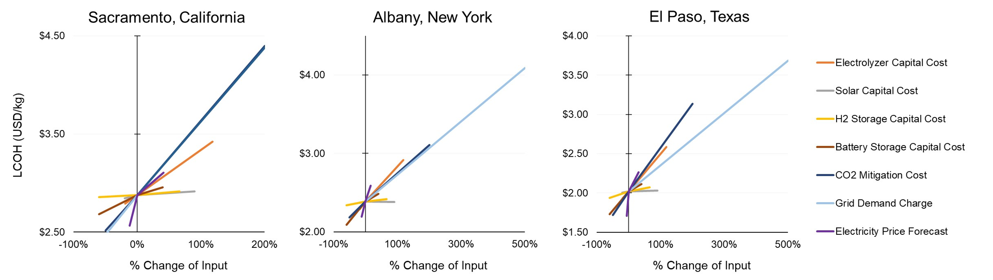

Figure S.1: PV/Storage/Grid* pathway spider plots with sensitivity results for 7 key input parameters

## Fossil-Based Hydrogen Production Parameter Sensitivity Analysis

This section contains the raw data tables for the fossil-based hydrogen production model sensitivity analysis. Sensitivity results shown in these raw data tables are for the *ATR-CSS* hydrogen production scenario. Spider plots with key parameter sensitivities are shown in Figure S.2. All low- and high-end input values are drawn from the current and mid-century assumptions, unless cited or stated otherwise in Table S.7.



Table S.7: LCOH sensitivities explored for next decade fossil-based hydrogen production via ATR-CCS

|  |  |  |
| --- | --- | --- |
| Parameter | Parameter Change: Lower LCOH | Parameter Change: Higher LCOH |
| CO2 Transport and Storage Cost | $10/ton CO2 [26] | $20/ton CO2 [26] |
| Economies of Scale Factor | 0.8 [23] | 0.55 [23] |
| Plant Life | 40 years  (+ 33% from base case) | 20 years  (- 33% from base case) |
| Grid Demand Charge | $5/kWe [17] | $30/kWe [17] |
| Hourly Grid Electricity Prices | Cambium: Low Renewable Energy Cost Scenario | Cambium: High Renewable Energy Cost Scenario |
| Natural Gas Processing Emissions | 0.1 kg CO2/kg CH4 [24] | 0.5 kg CO2/kg CH4 [24] |
| Discount Rate (WACC) | 4% [21]  (20% less than base case) | 10% [3] |
| GWP Timeframe | 100-year [27] | 20-year [27] |
| Facility Size | 500 ton/day | 25 ton/day |
| Natural Gas Price | $2.84/GJ ($3/MMBTU)  [22] | $14.22/GJ ($15/MMBTU)  [22], [29] |
| Natural Gas Leakage Rate (GWP20) | 0%  (CH4 releases are mitigated) | 4% [30], [31] |
| CO2 Removal Cost | $100/ton CO2 | $600/ton CO2 |

Table S.8: Hourly reliable (ATR with process CO2 capture) LCOH sensitivity analysis with next decade technology



|  |  |  |  |  |  |  |
| --- | --- | --- | --- | --- | --- | --- |
| Parameter | Lower LCOH | | | Higher LCOH | | |
| CA | NY | TX | CA | NY | TX |
| CO2 Transport and Storage Cost | $3.28 | $2.97 | $2.78 | $3.37 | $3.06 | $2.86 |
| Economies of Scale Factor | $3.18 | $2.88 | $2.68 | $3.31 | $3.00 | $2.80 |
| Plant Life | $3.24 | $2.93 | $2.74 | $3.37 | $3.06 | $2.87 |
| Grid Demand Charge | $3.25 | $2.97 | $2.78 | $3.39 | $3.11 | $2.91 |
| Grid Electricity Cost | $3.25 | $2.96 | $2.75 | $3.33 | $2.99 | $2.85 |
| Natural Gas Processing Emissions | $3.14 | $2.83 | $2.64 | $3.42 | $3.11 | $2.92 |
| Discount Rate (WACC) | $3.24 | $2.93 | $2.73 | $3.53 | $3.22 | $3.02 |
| GWP Timeframe | $2.70 | $2.39 | $2.20 | $3.28 | $2.97 | $2.78 |
| Facility Size | $3.15 | $2.84 | $2.65 | $4.09 | $3.78 | $3.59 |
| Natural Gas Price | $2.67 | $2.63 | $2.60 | $4.75 | $4.71 | $4.69 |
| Natural Gas Leakage Rate (GWP20) | $2.38 | $2.07 | $1.88 | $4.78 | $4.47 | $4.27 |
| CO2 Removal Cost | $2.64 | $2.35 | $2.14 | $5.82 | $5.45 | $5.32 |

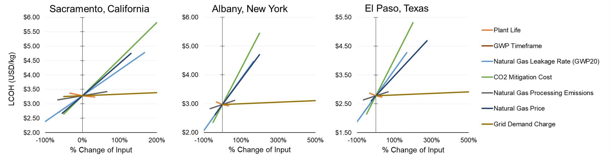

Figure S.2: ATR-CCS pathway spider plots with sensitivity results for 7 key input parameters

## Next-Decade LCOH Input Parameter Sample Distributions for Error Bar Analysis

The raw data table (Table S.9) in this section contains details on the distributions chosen for each input parameter. Monte Carlo simulation is performed using the information in this raw data table to generate the errors bars in main text Figure 4. For most input parameters, triangular distributions are chosen with lower and upper bounds of the distributions set as the current and mid-century technology options from Tables S.1 and S.4. All other low- and high-end bound in Table S.9 are drawn from Tables S.5 and S.7 or are cited in Table S.9. Notably, we sample from three different 2035 grid pricing and emission scenarios for each state. These scenarios are pulled from NREL’s Cambium database and are listed as: Mid Case (base), Mid Case with Low Renewable Energy Costs, and Mid Case with High Renewable Energy Costs.

Table S.9: Summary data table containing sample distributions for each input parameter. These distributions are used to generate error bars on next-decade LCOH figures through Monte Carlo simulation.

|  |  |  |  |  |  |  |
| --- | --- | --- | --- | --- | --- | --- |
| Parameters | | Distribution Type | Low Value | High Value | Base Value | Units |
| Electricity-Based H2 | Electrolyzer Efficiency | Triangular | 60 | 70 | 65 | % |
| Electrolyzer Capital Cost | Triangular | 340 | 915 | 340 | $/kWe |
| Solar Capital Cost | Triangular | 400 | 950 | 400 | $/kWe |
| H2 Storage Capital Cost | Triangular | 200 | 830 | 500 | $/kg |
| Battery Storage Capital Cost | Triangular | 100 | 350 | 250 | $/kWhe |
| Solar Land Cost | Triangular | 500 [12] | 1250 [12] | 750 [12] | $/acre/yr |
| Project Life | Triangular | 20 | 30 | 25 | Years |
| WACC | Triangular | 5 | 10 | 8 | % |
| Solar Life Cycle Emissions | Triangular | 0 | 0.05 | 0.04 | kg CO2/kWhe |
| Fossil-Based H2 | Plant Life | Triangular | 20 | 40 | 30 | Years |
| WACC | Triangular | 4 | 10 | 4 | % |
| Economies of Scale Factor | Triangular | 0.55 | 0.8 | 0.6 | N/A |
| Natural Gas GWP | Binomial | 30 | 85 | N/A | kg CO2e/kg CH4 |
| Natural Gas Leakage Rate | Uniform | 0 | 4 | N/A | % |
| Natural Gas Processing Emissions | Triangular | 0.1 | 0.5 | 0.3 | kg CO2/kg CH4 |
| Natural Gas Price | Triangular | 3 | 15 | 3 | $/MMBTU |
| CO2 Transport and Storage Cost | Triangular | 10 | 20 | 10 | $/metric ton CO2 |
| Electricity- and Fossil-Based H2 | Grid Electricity Cost and Emissions | Multinomial | Cambium: Low RE Cost Mid-Case | Cambium: High RE Cost Mid-Case | Cambium: Mid-Case | $/kWhe each hour |
| Grid Connection Capital Cost | Triangular | 45 | 340 | 180 | $/kWe |
| Demand Charges | Triangular | 0 | 30 | 10 (CA)  5 (NY, TX) | $/max kWe/month |
| Life-Cycle Grid Emissions | Multinomial | Cambium: Low RE Cost Mid-Case | Cambium: High RE Cost Mid-Case | Cambium: Mid-Case | kg CO2/kWhe each hour |
| Carbon Removal Cost | Triangular | 100 | 600 | 100 | $/metric ton CO2 |

## Next Decade Technology Hydrogen Production Pathway Emissions and LCOH Figures

This section includes figures of the GHG emissions for each next-decade hydrogen production pathway explored in the study. It also includes a detailed cost breakdown figure for each hourly-reliable fossil-based production pathway in each state, since this was not included in the main text.

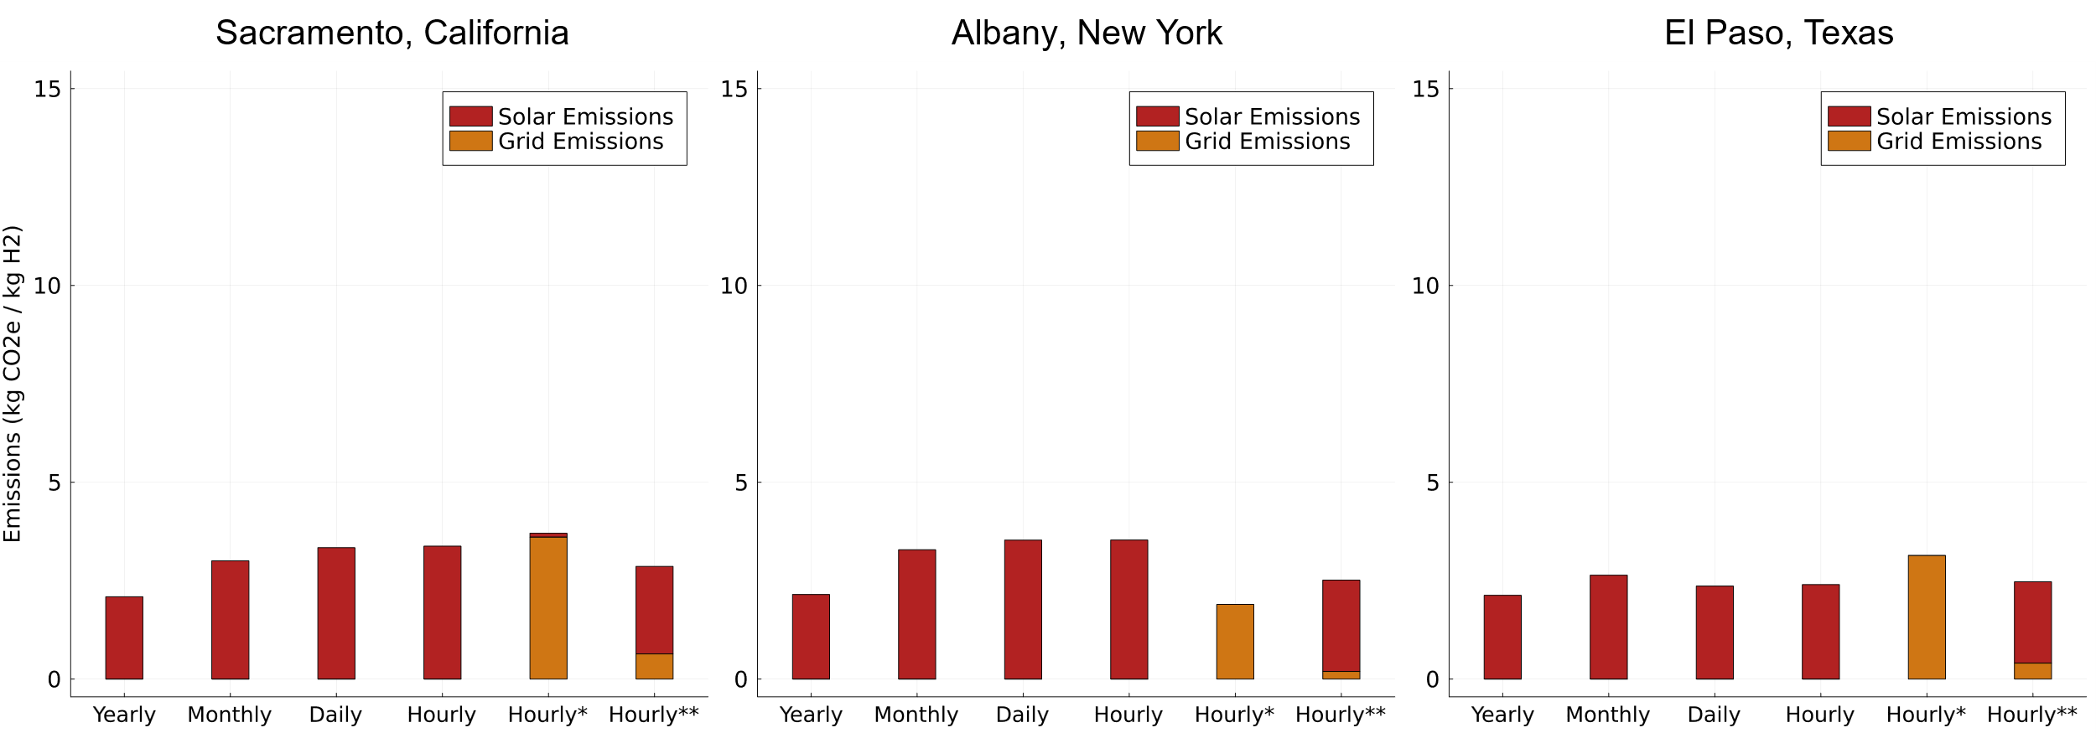

Figure S.3: Next decade GHG emissions of solar PV-based hydrogen production under various levels of reliability. *Indicates an hourly-reliable production pathway that has an unconstrained grid connection for added reliability. ** Indicates and hourly-reliable production pathway that has a constrained grid connection (only 10% of the total electricity used at the facility can be from the grid) for added reliability.

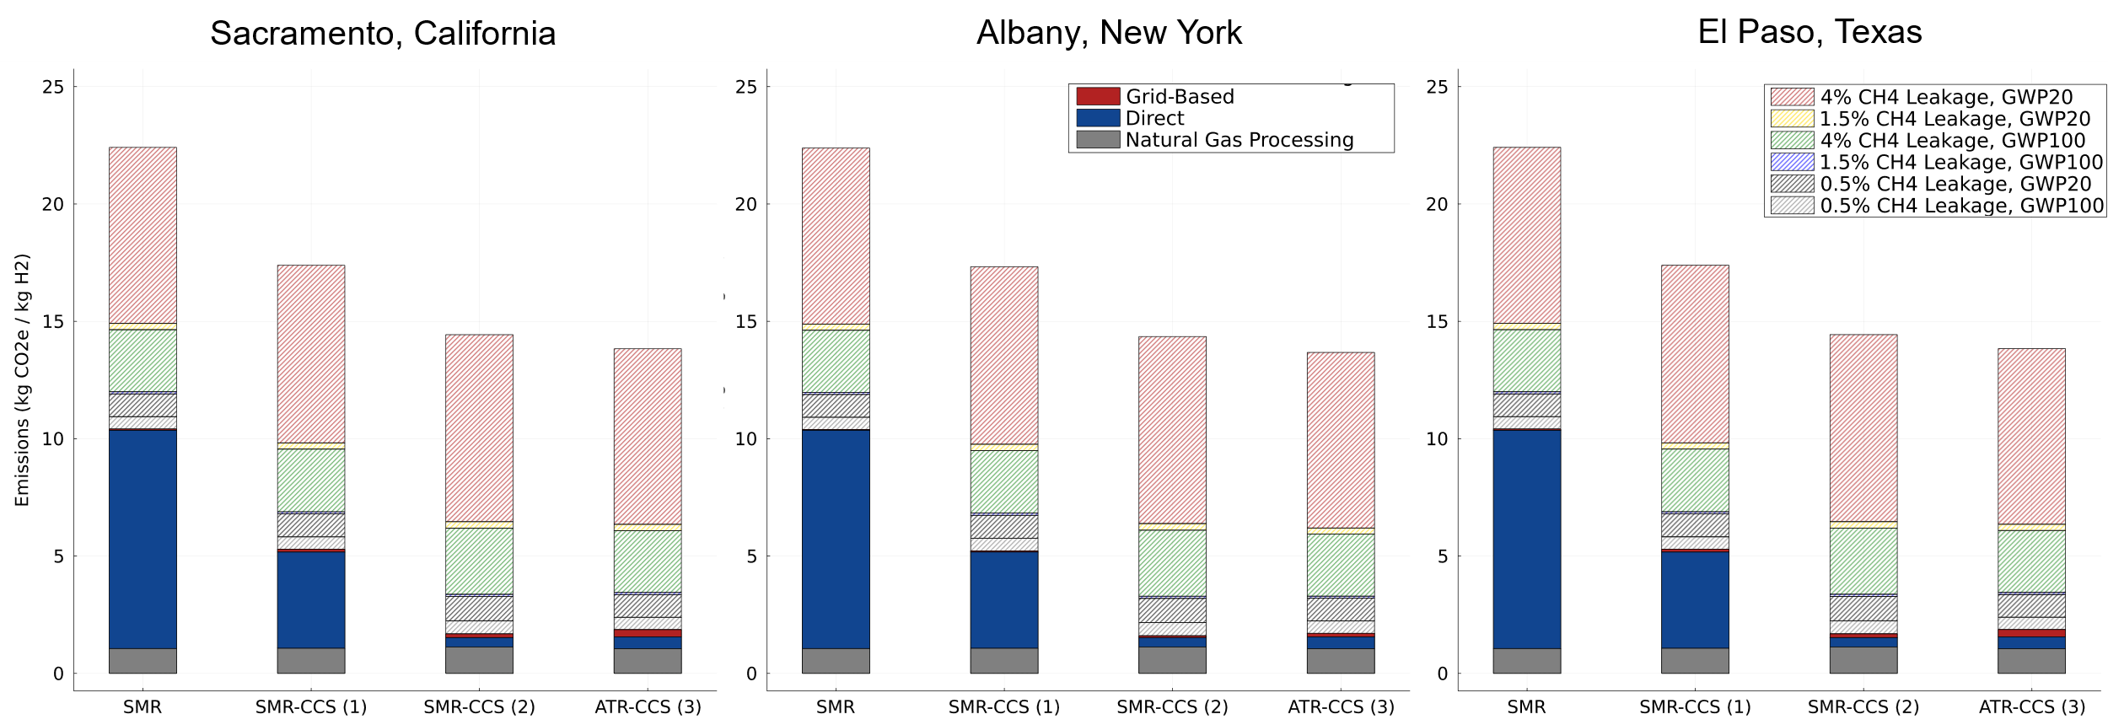

Figure S.4: Next-decade GHG emissions of various fossil-based hydrogen production pathways

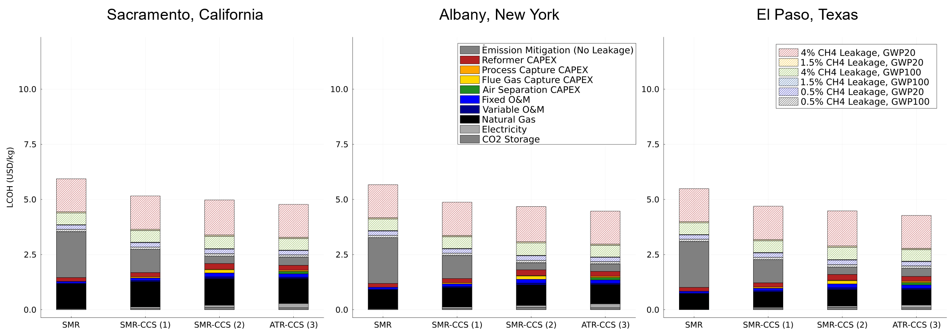

Figure S.5: Levelized cost of hourly-reliable net-zero hydrogen produced from fossil-based pathways. Pathways include SMR, SMR-CCS with process CO2 capture (1), SMR-CCS with process and flue gas CO2 capture (2), and ATR-CCS with process CO2 capture (3)

## Electricity-Based Hydrogen Production Pathway Operations Figures

This section contains figures detailing electricity usage and curtailment for the electricity-based hydrogen production pathways under next-decade technology assumptions. Figures S.8 - S.22 show hourly and daily operations data specific to the California location.

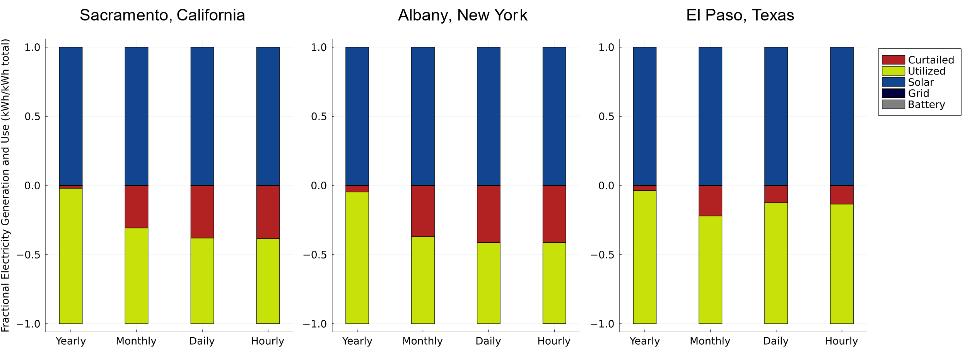

Figure S.6: Next decade electricity utilization for various levels of hydrogen production reliability pathways. Above the x-axis shows the fraction of electricity input from solar PV, the grid, or an onsite battery. Below the y-axis shows the fraction of the electricity input that is utilized or curtailed. Grid and battery electricity inputs are at or near zero in these pathways.

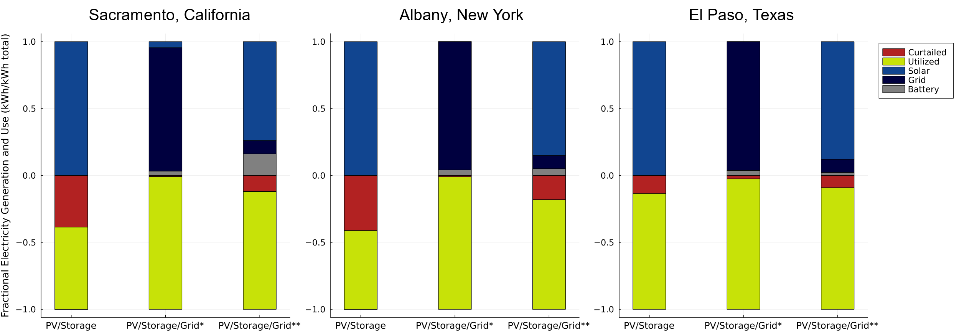

Figure S.7: Next decade electricity utilization for hourly production reliability pathways. Above the x-axis shows the fraction of electricity input from solar PV, the grid, or an onsite battery. Below the y-axis shows the fraction of the electricity input that is utilized or curtailed.

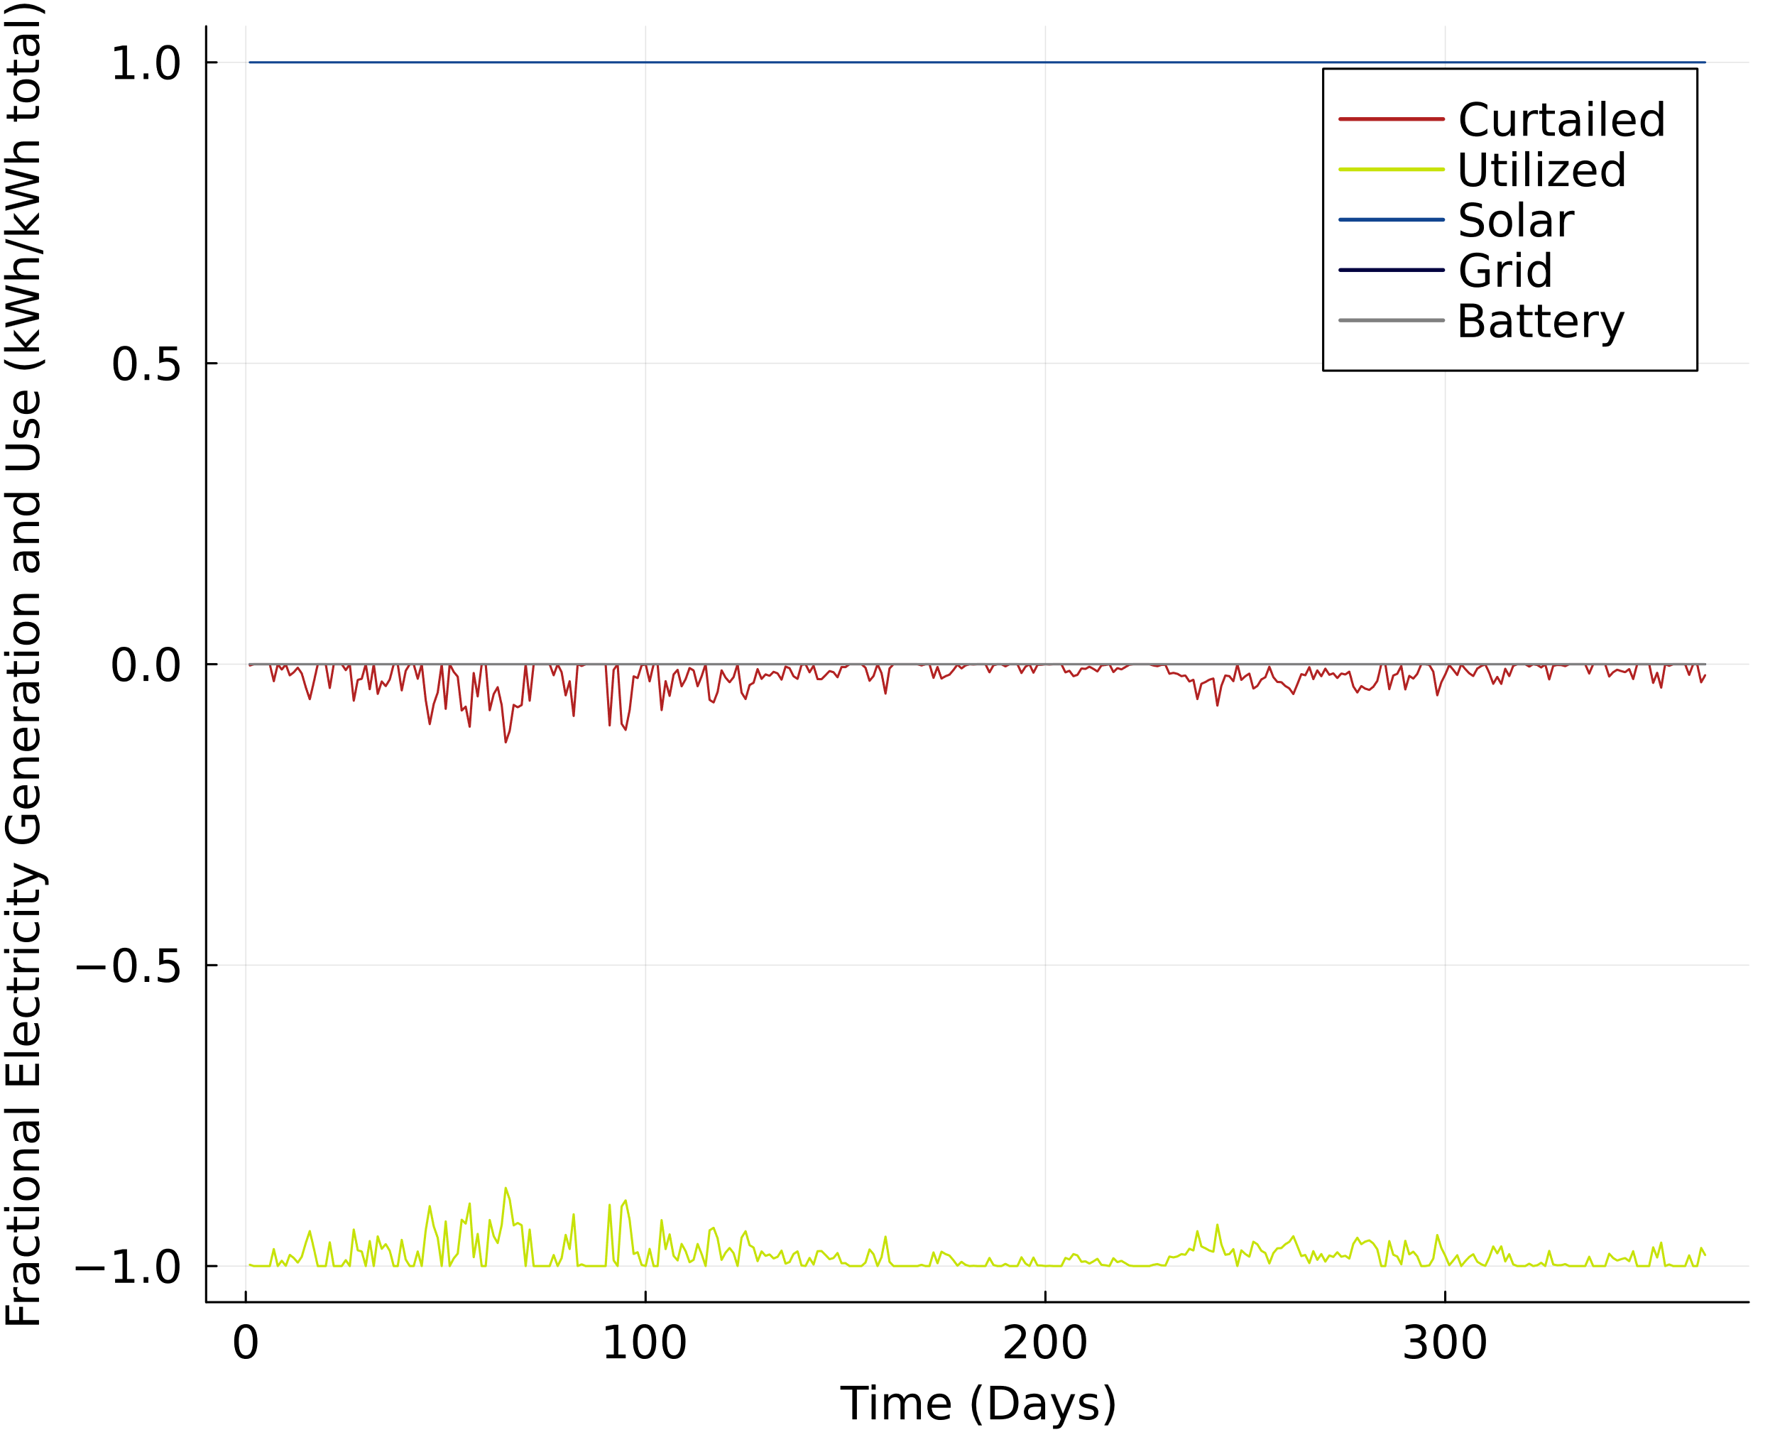

Figure S.8: Daily electricity utilization for the yearly reliable solar PV hydrogen production pathway in Sacramento, California. Above the x-axis shows the daily fraction of electricity input from solar PV, the grid, or an onsite battery. Below the y-axis shows the daily fraction of the electricity input that is utilized or curtailed. Grid and battery electricity inputs are at or near zero in this pathway.

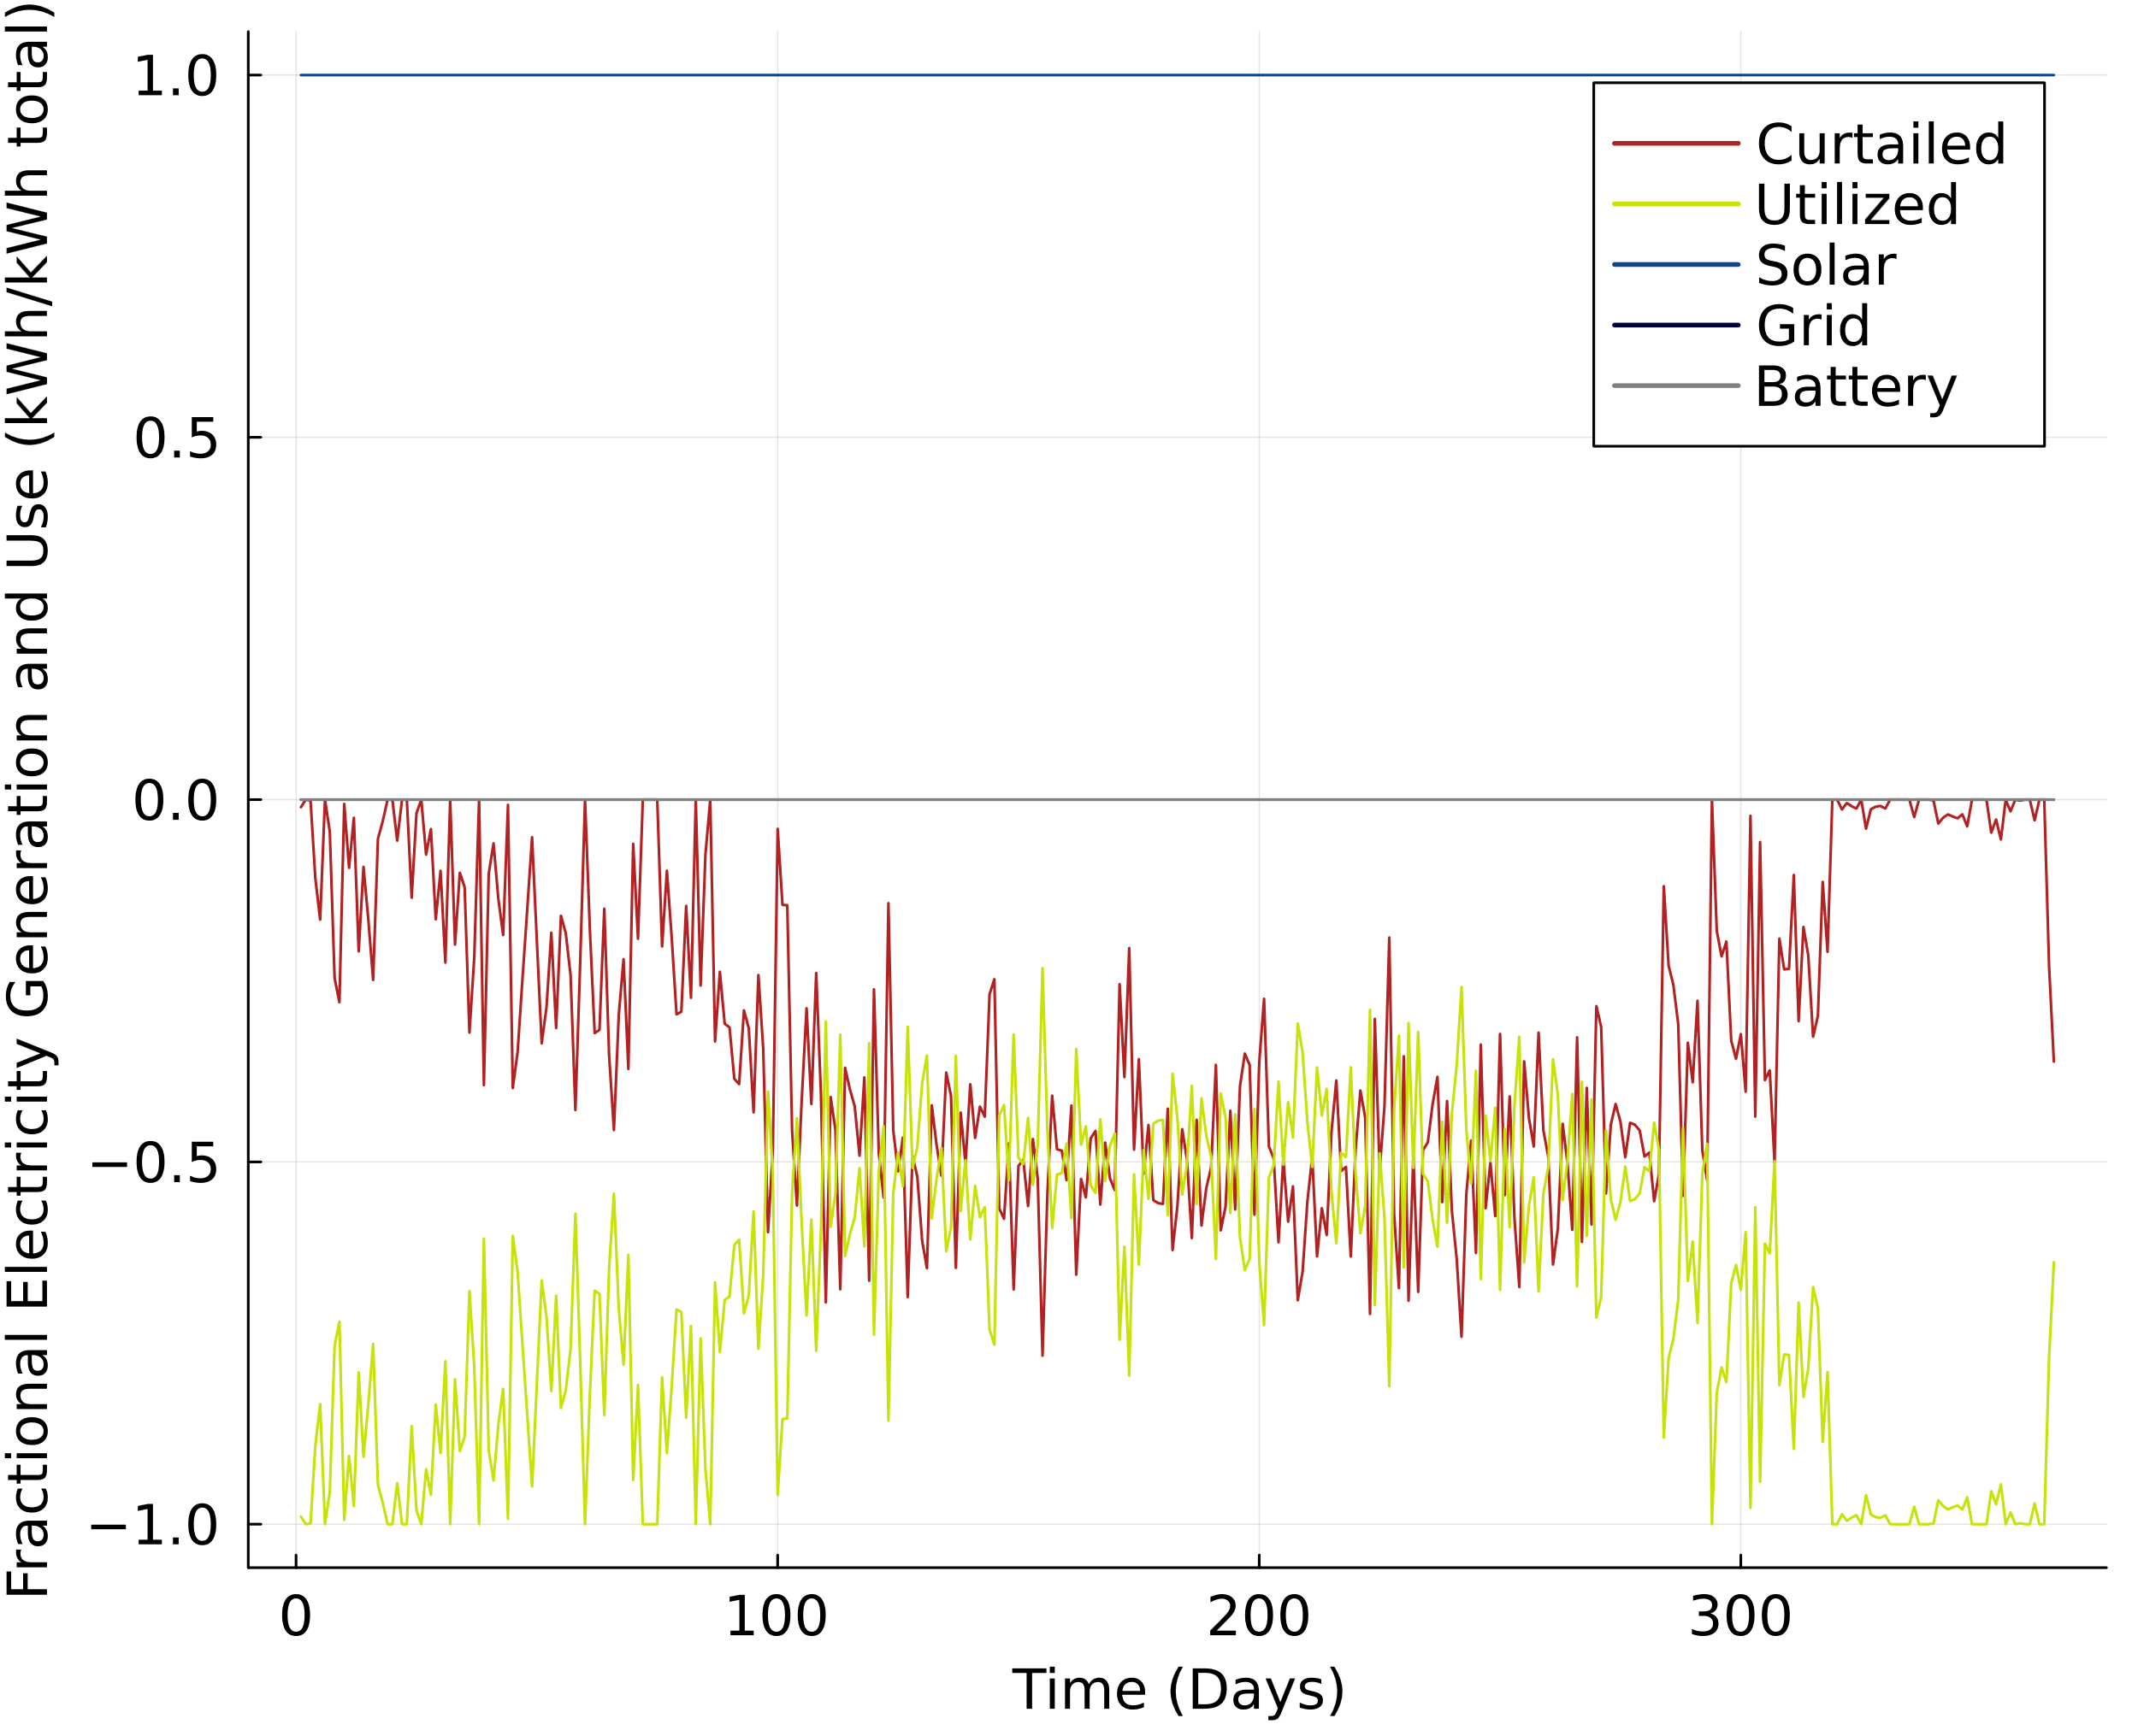

Figure S.9: Daily electricity utilization for the hourly reliable solar PV with storage hydrogen production pathway in Sacramento, California. Above the x-axis shows the daily fraction of electricity input from solar PV, the grid, or an onsite battery. Below the y-axis shows the daily fraction of the electricity input that is utilized or curtailed. Grid and battery electricity inputs are at or near zero in this pathway.

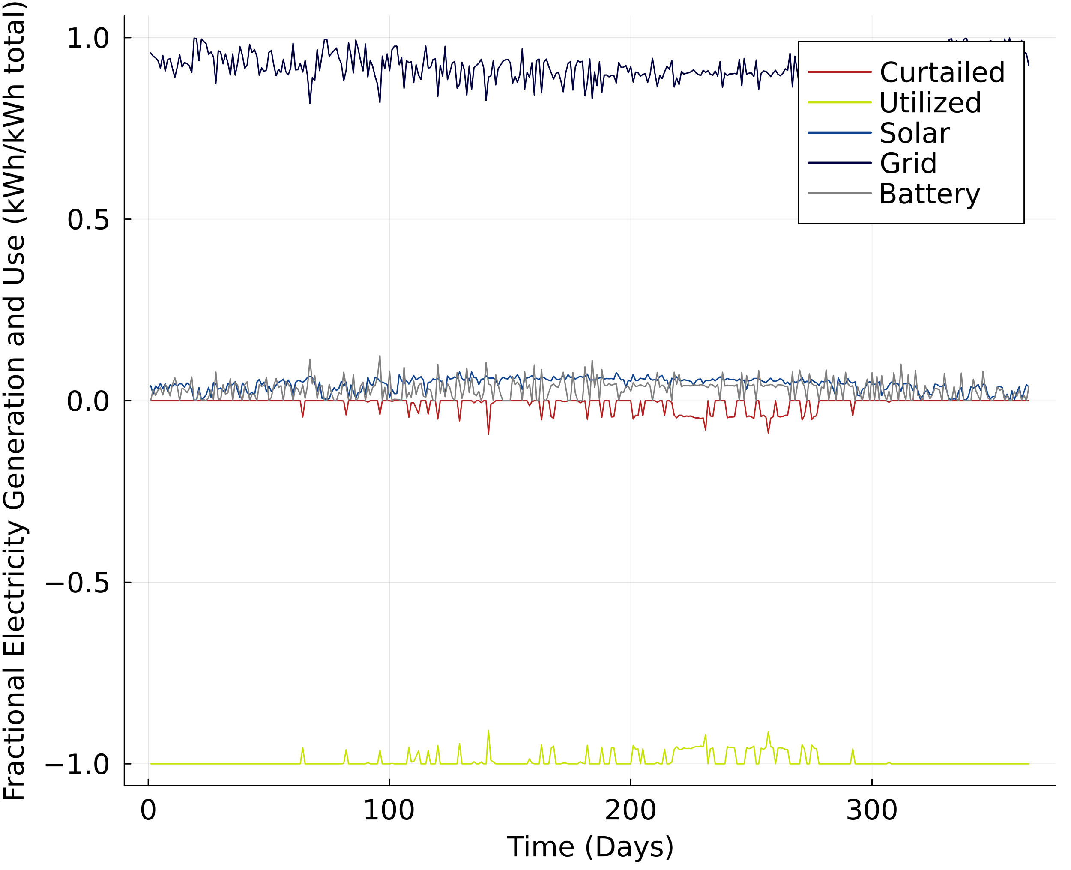

Figure S.10: Daily electricity utilization for the hourly reliable solar PV, storage, and grid connected hydrogen production pathway in Sacramento, California (Equivalent to PV/Storage/Grid* pathway). Above the x-axis shows the daily fraction of electricity input from solar PV, the grid, or an onsite battery. Below the y-axis shows the daily fraction of the electricity input that is utilized or curtailed.

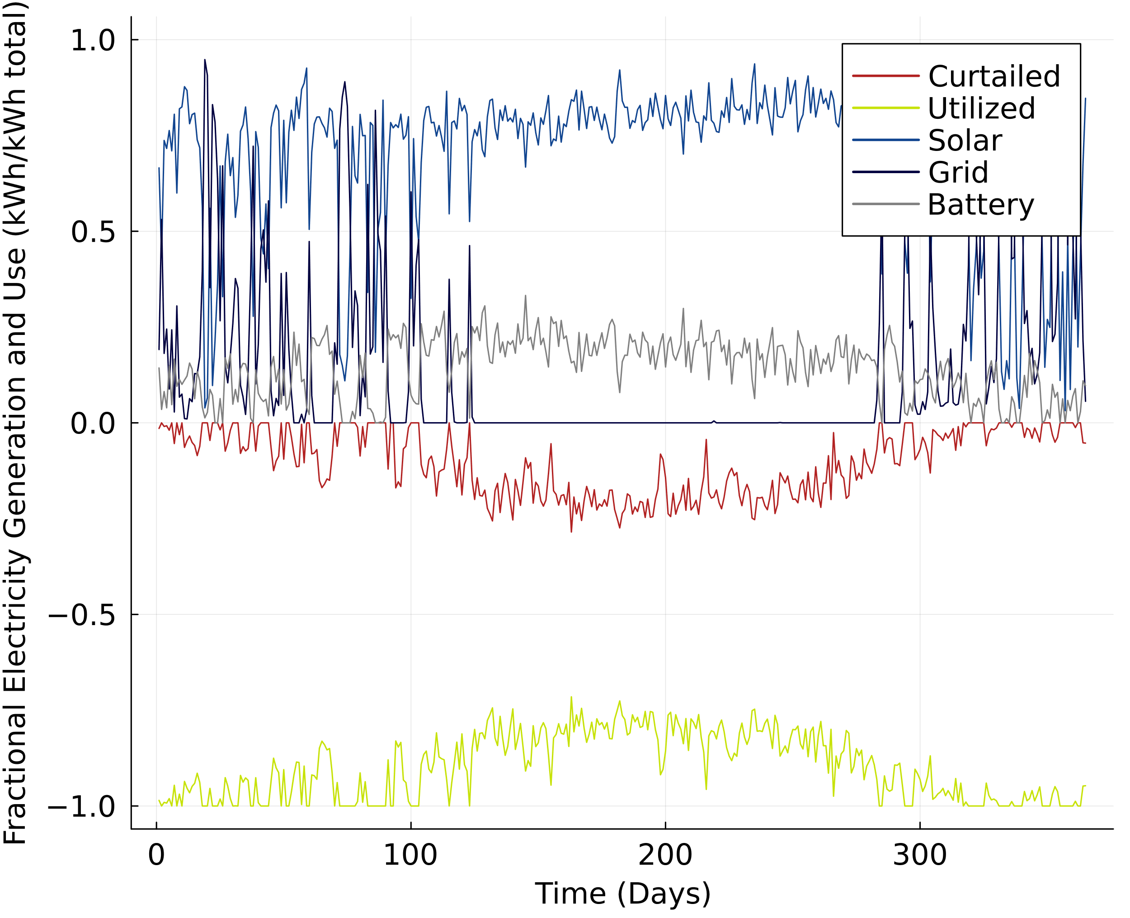

Figure S.11: Daily electricity utilization for the hourly reliable solar PV, storage, and limited grid connected hydrogen production pathway in Sacramento, California (Equivalent to PV/Storage/Grid** pathway). Above the x-axis shows the daily fraction of electricity input from solar PV, the grid, or an onsite battery. Below the y-axis shows the daily fraction of the electricity input that is utilized or curtailed.

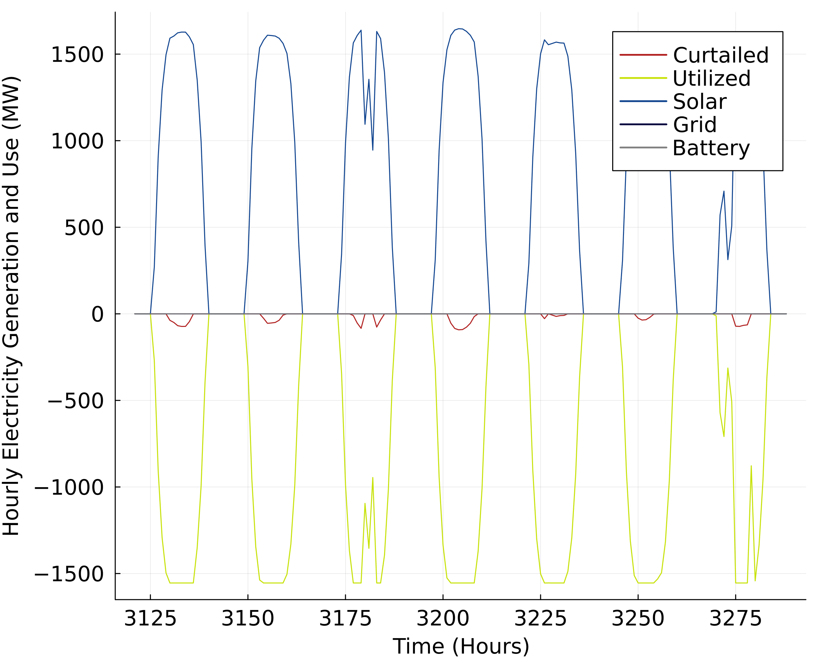

Figure S.12: Hourly electricity utilization for the yearly reliable solar PV hydrogen production pathway for a week in the month of May in Sacramento, California. Above the x-axis shows the hourly electricity input from solar PV, the grid, or an onsite battery. Below the y-axis shows the hourly electricity input that is utilized or curtailed. Grid and battery electricity inputs are at or near zero in this pathway.

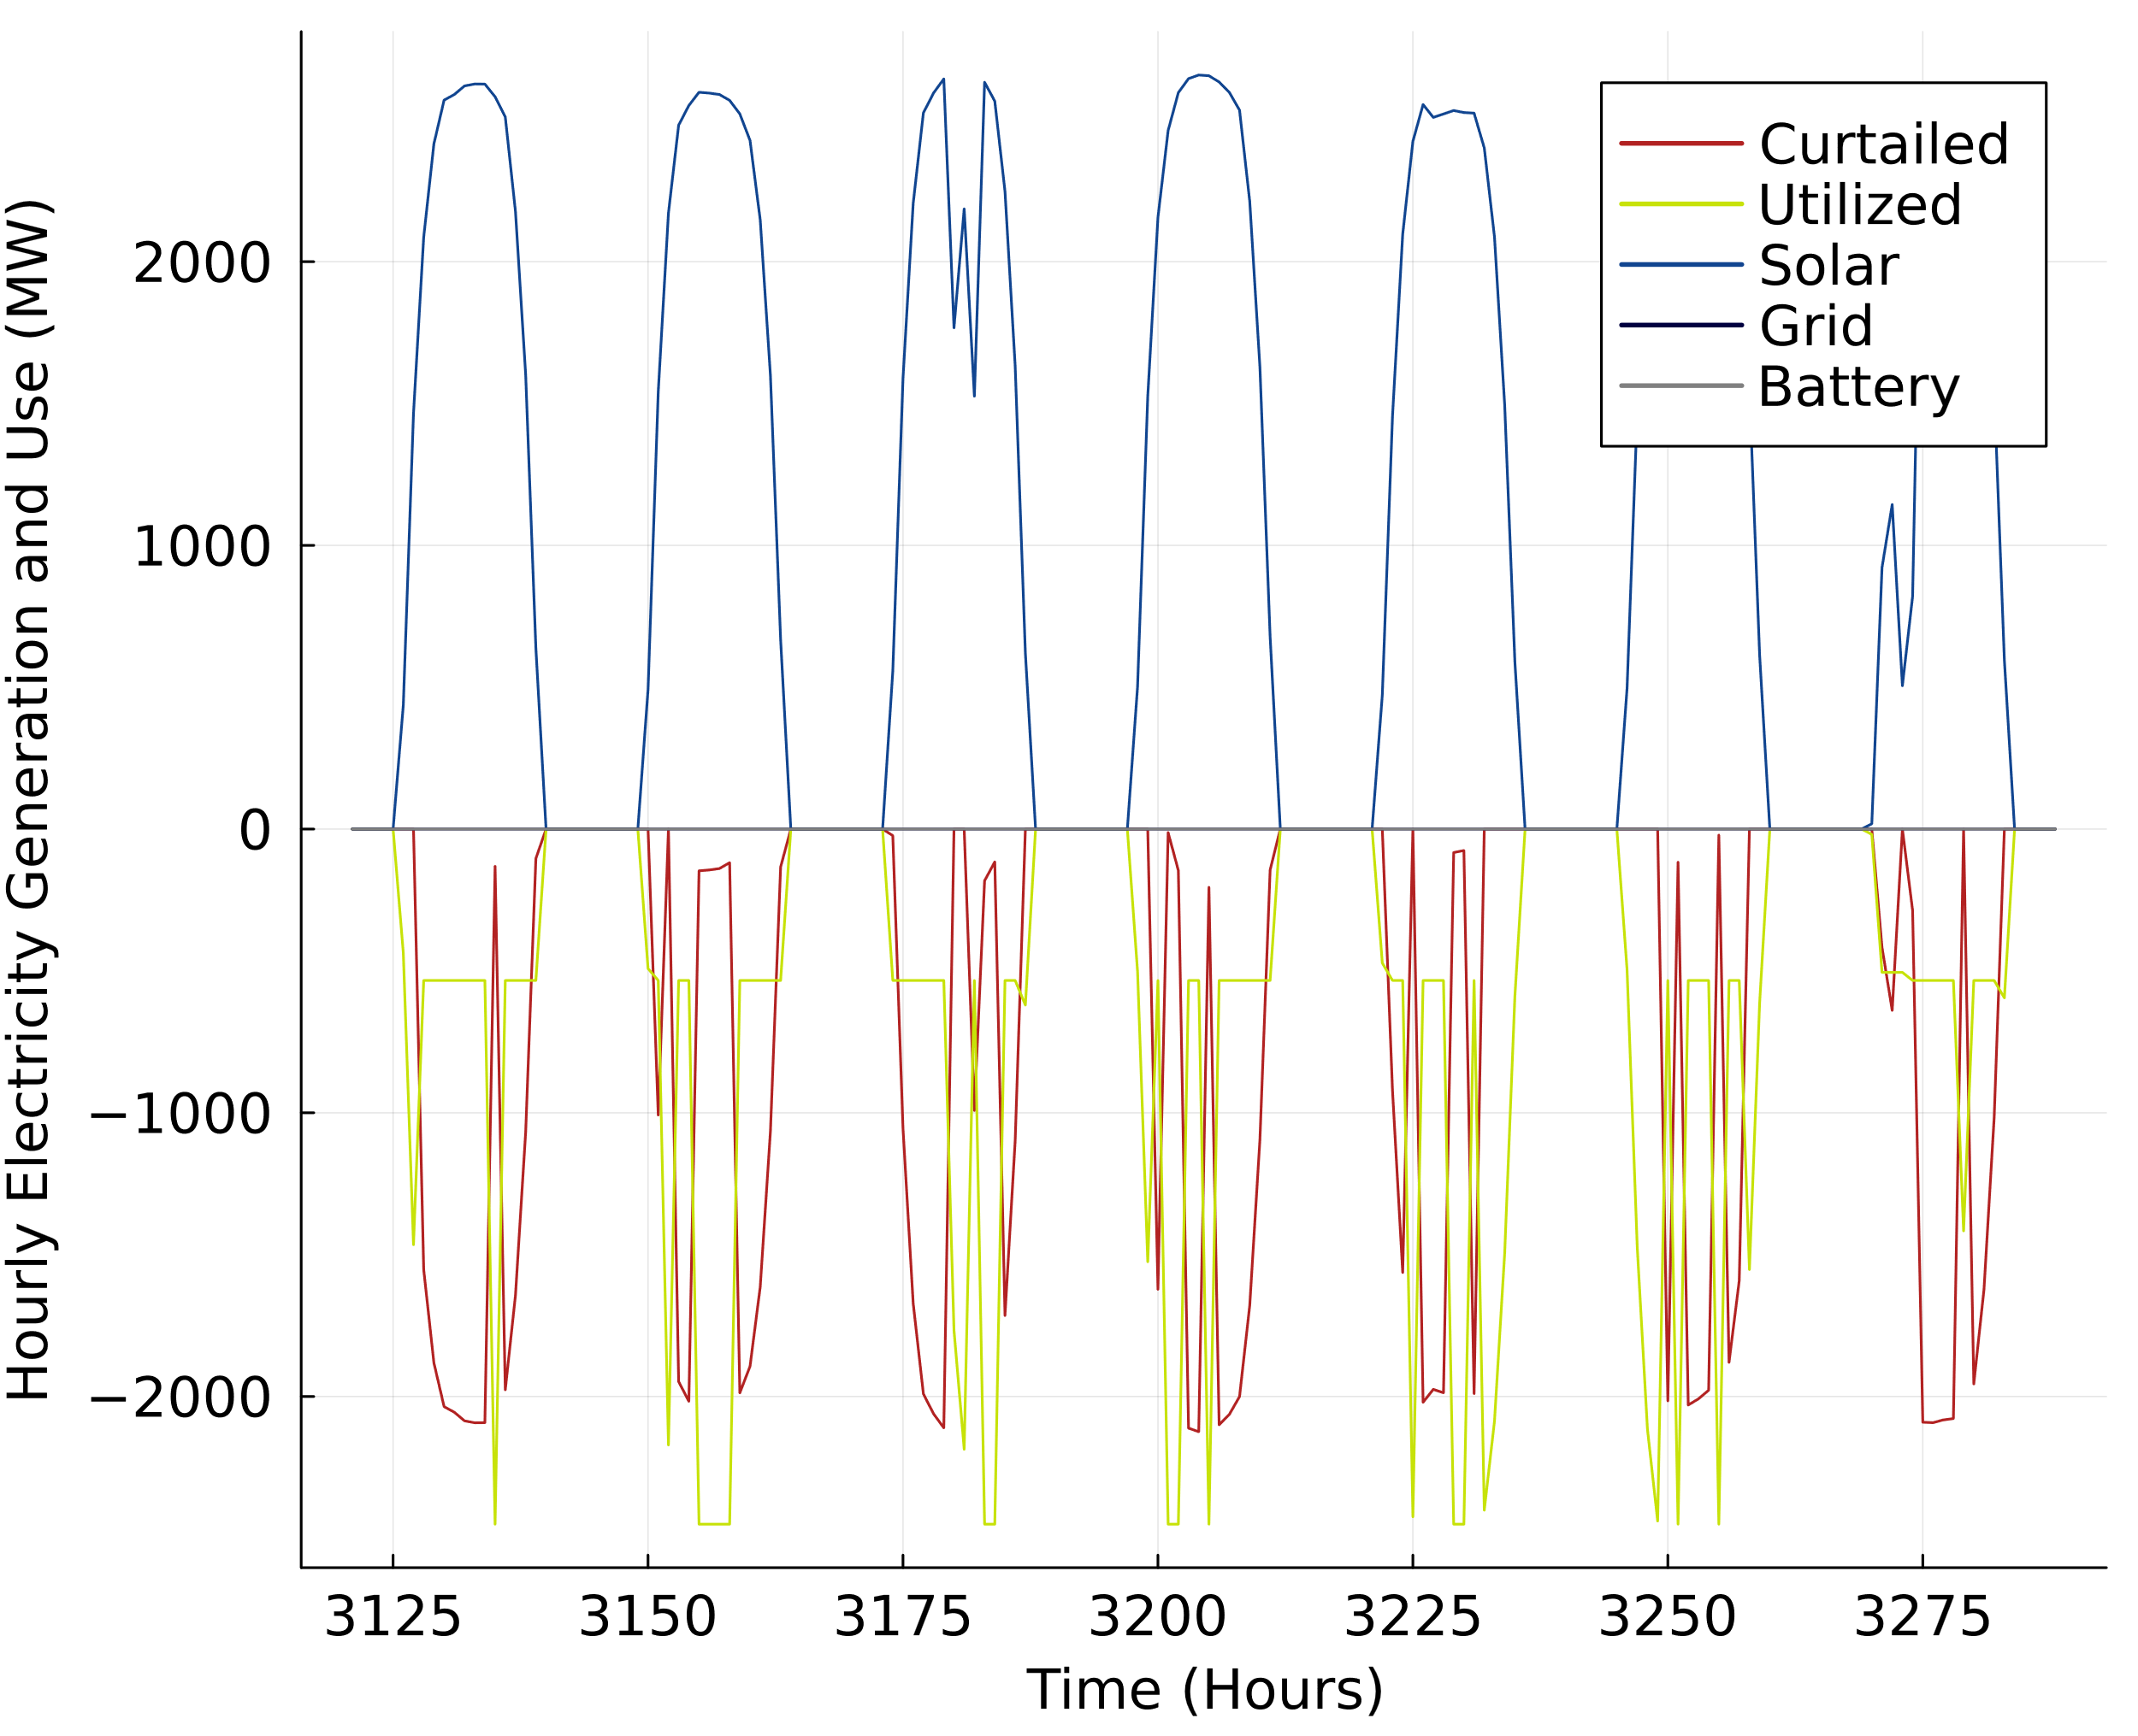

Figure S.13: Hourly electricity utilization for the hourly reliable solar PV and storage hydrogen production pathway for a week in the month of May in Sacramento, California (Equivalent to PV/Storage pathway). Above the x-axis shows the hourly electricity input from solar PV, the grid, or an onsite battery. Below the y-axis shows the hourly electricity input that is utilized or curtailed. Grid and battery electricity inputs are at or near zero in this pathway.

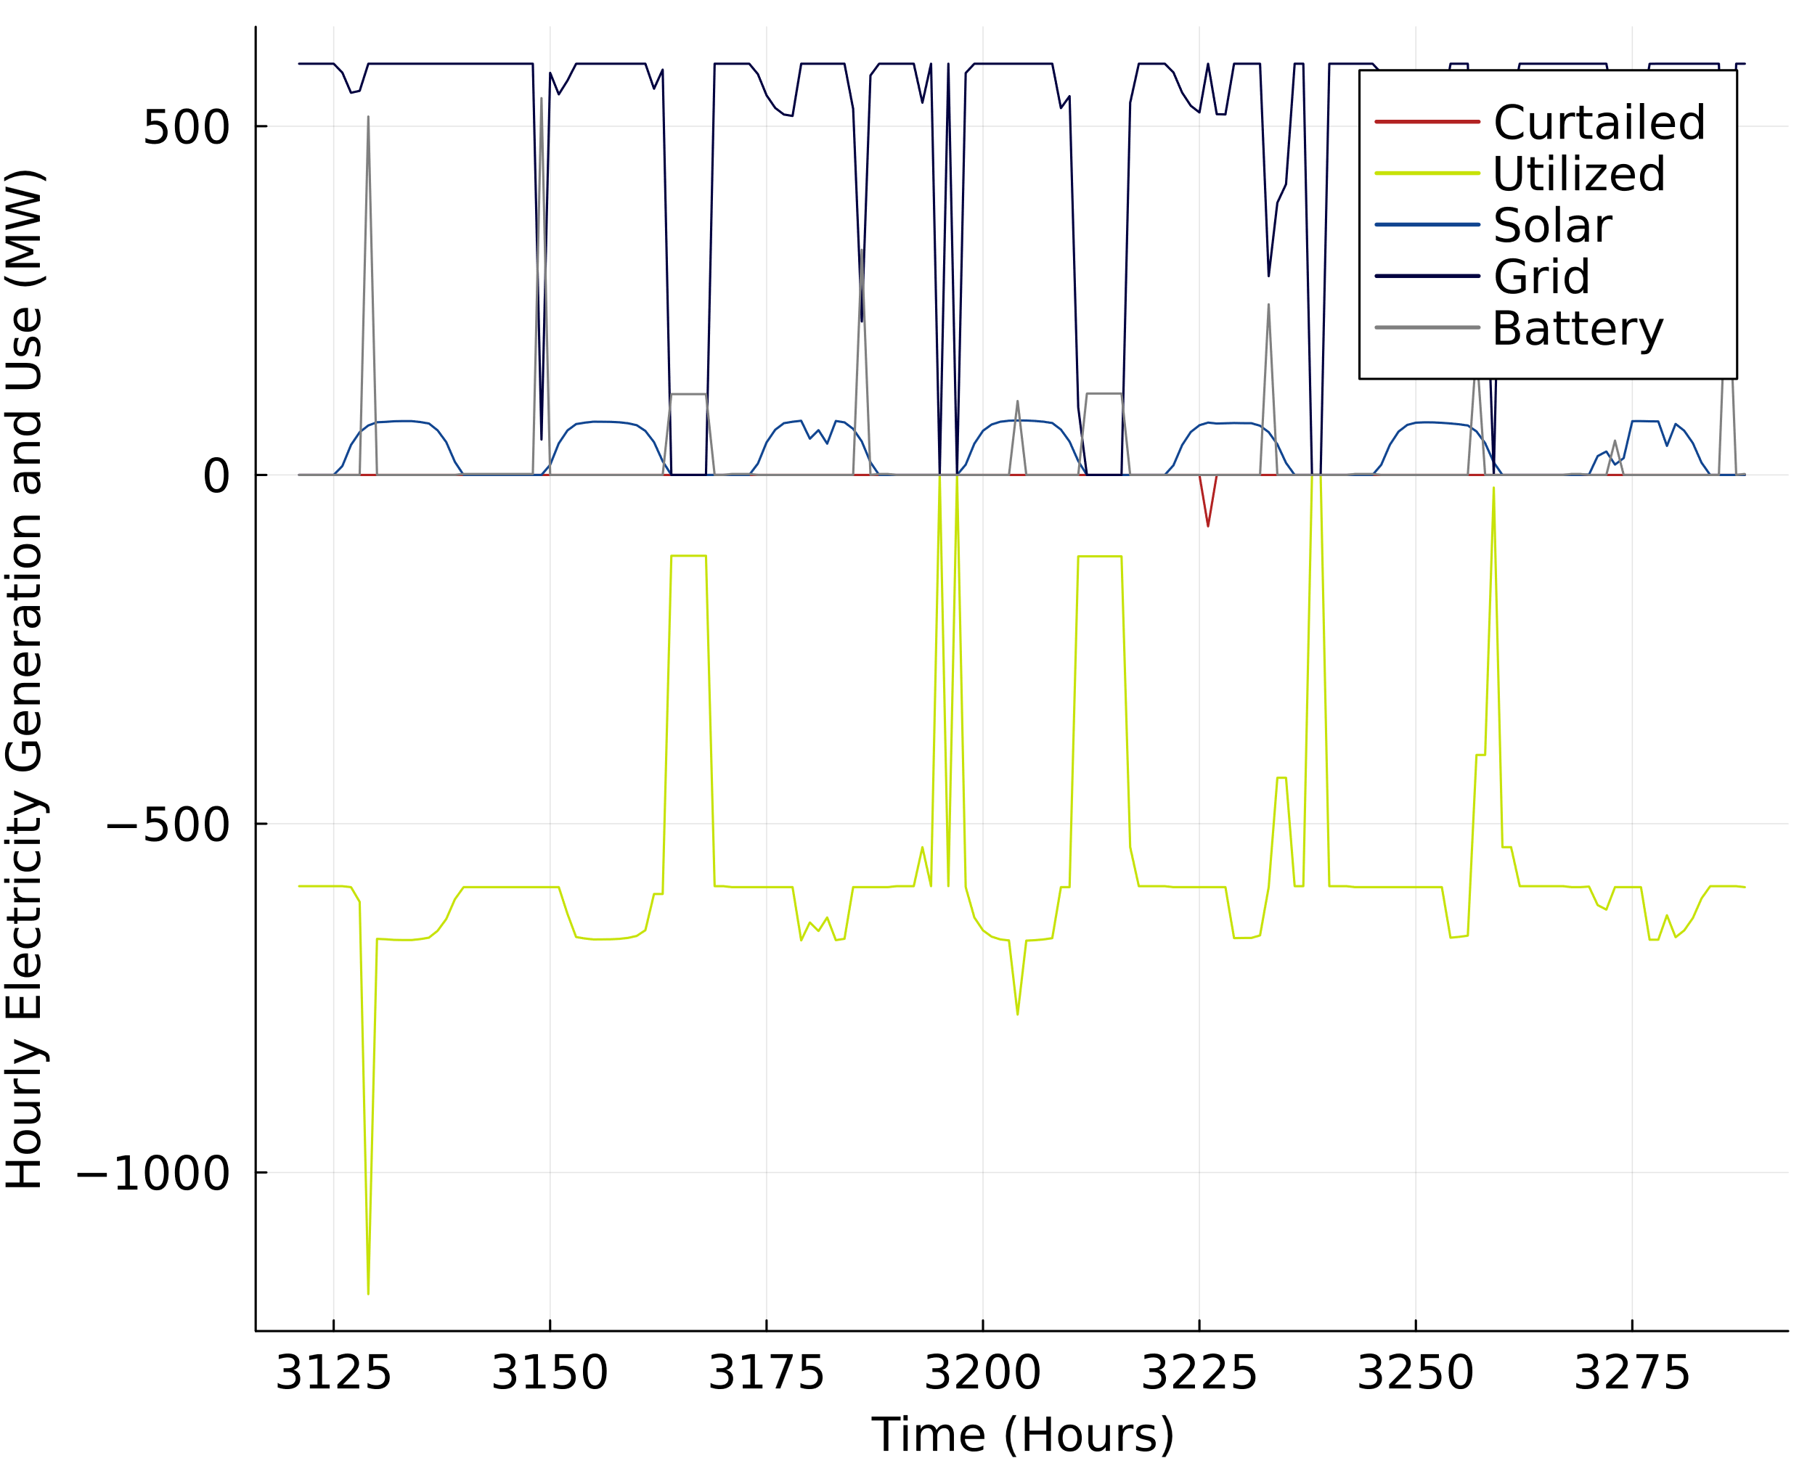

Figure S.14: Hourly electricity utilization for the hourly reliable solar PV, storage, and grid connected hydrogen production pathway for a week in the month of May in Sacramento, California (Equivalent to PV/Storage/Grid* pathway). Above the x-axis shows the hourly electricity input from solar PV, the grid, or an onsite battery. Below the y-axis shows the hourly electricity input that is utilized or curtailed.

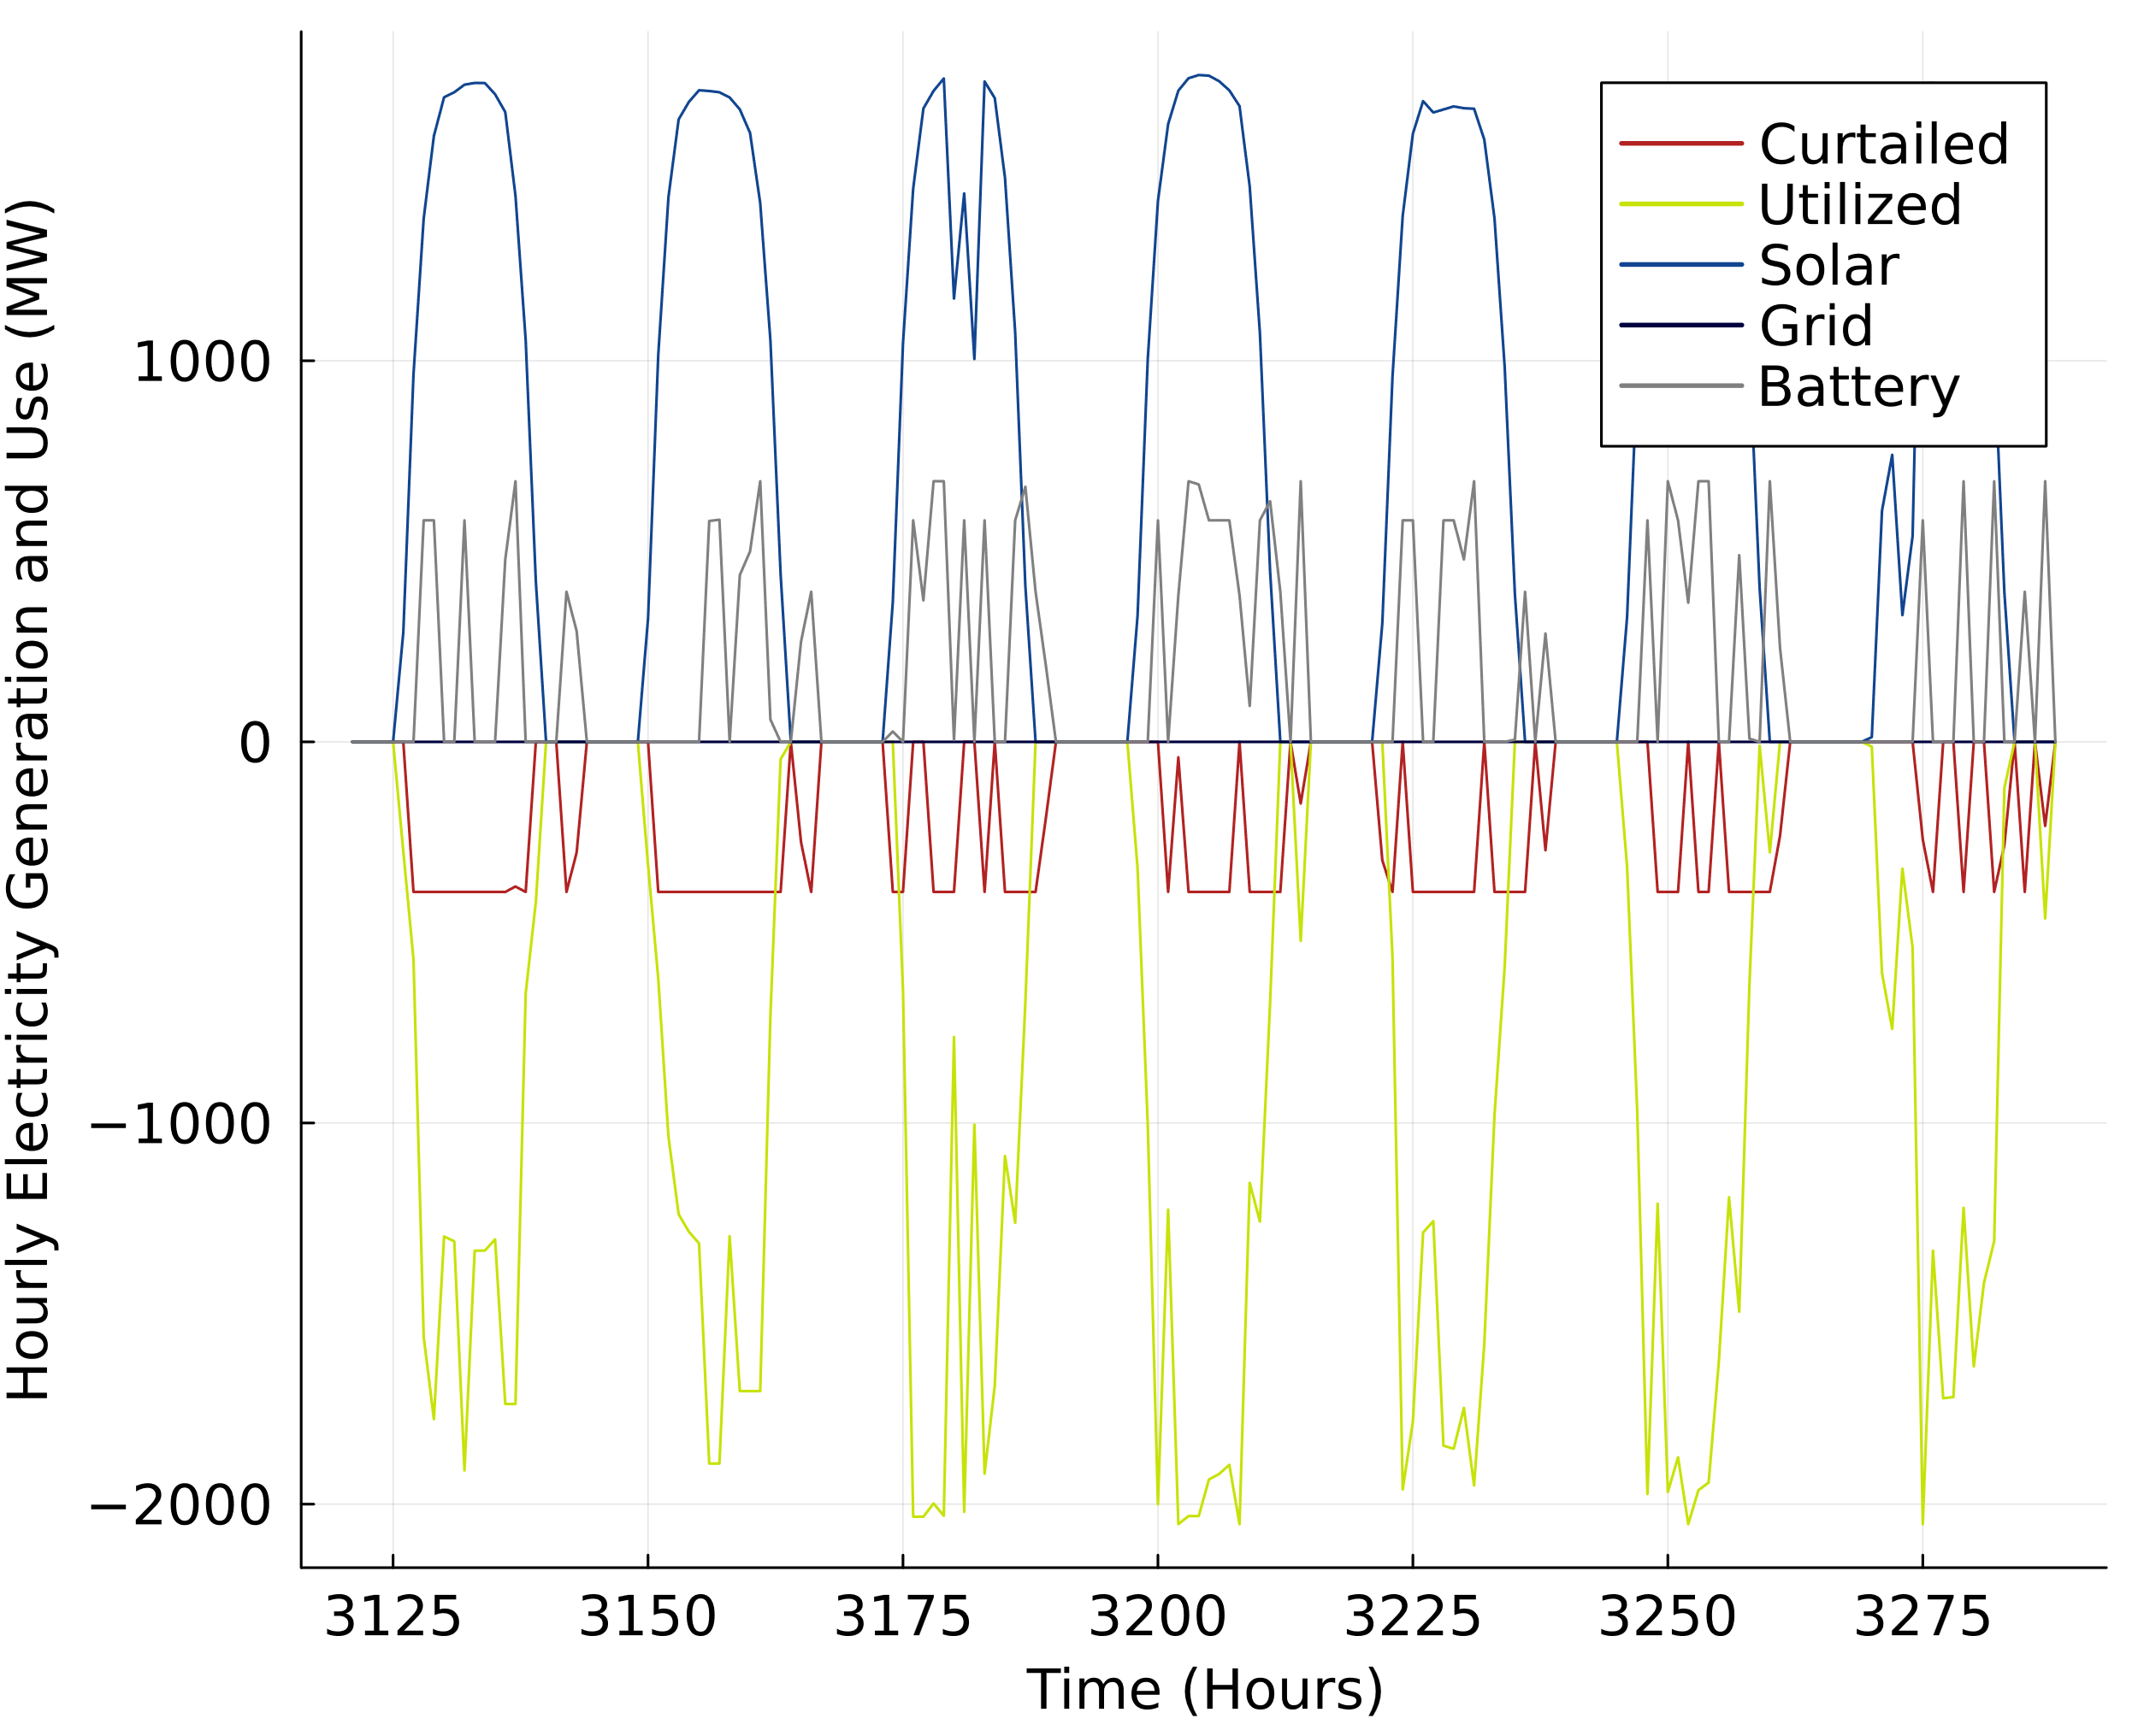

Figure S.15: Hourly electricity utilization for the hourly reliable solar PV, storage, and limited grid connected hydrogen production pathway for a week in the month of May in Sacramento, California (Equivalent to PV/Storage/Grid** pathway). Above the x-axis shows the hourly electricity input from solar PV, the grid, or an onsite battery. Below the y-axis shows the hourly electricity input that is utilized or curtailed.

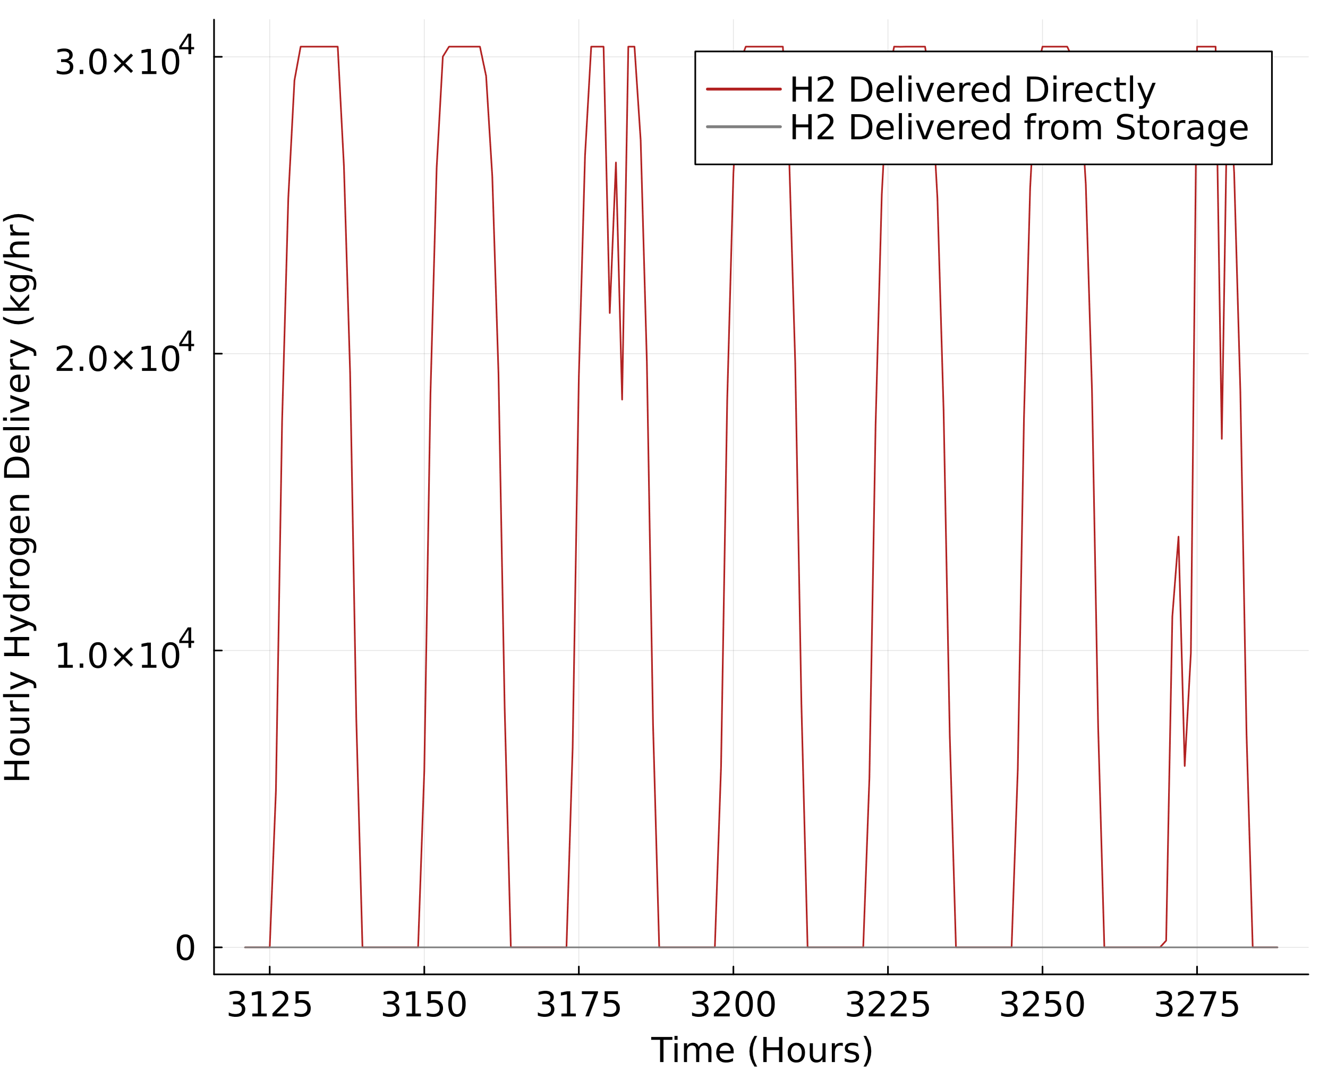

Figure S.16: Hourly hydrogen delivery for yearly reliable solar PV hydrogen production for a week in the month of May in Sacramento, California

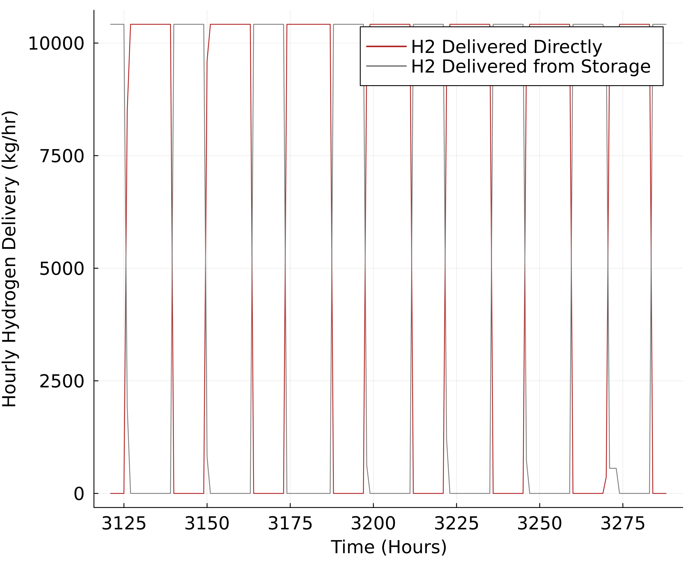

Figure S.17: Hourly hydrogen delivery for hourly reliable solar PV and storage hydrogen production pathway for a week in the month of May in Sacramento, California (Equivalent to PV/Storage pathway).

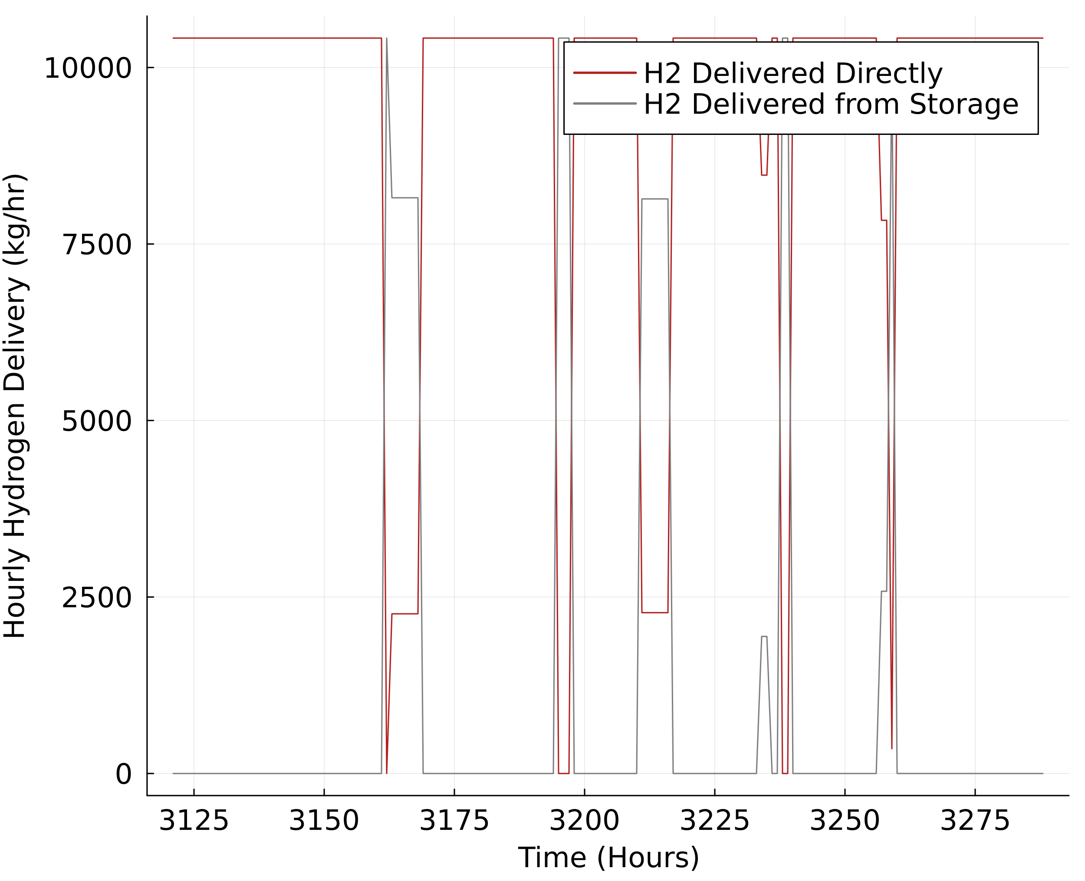

Figure S.18: Hourly hydrogen delivery for hourly reliable solar PV, storage, and grid connected hydrogen production pathway for a week in the month of May in Sacramento, California (Equivalent to PV/Storage/Grid* pathway).

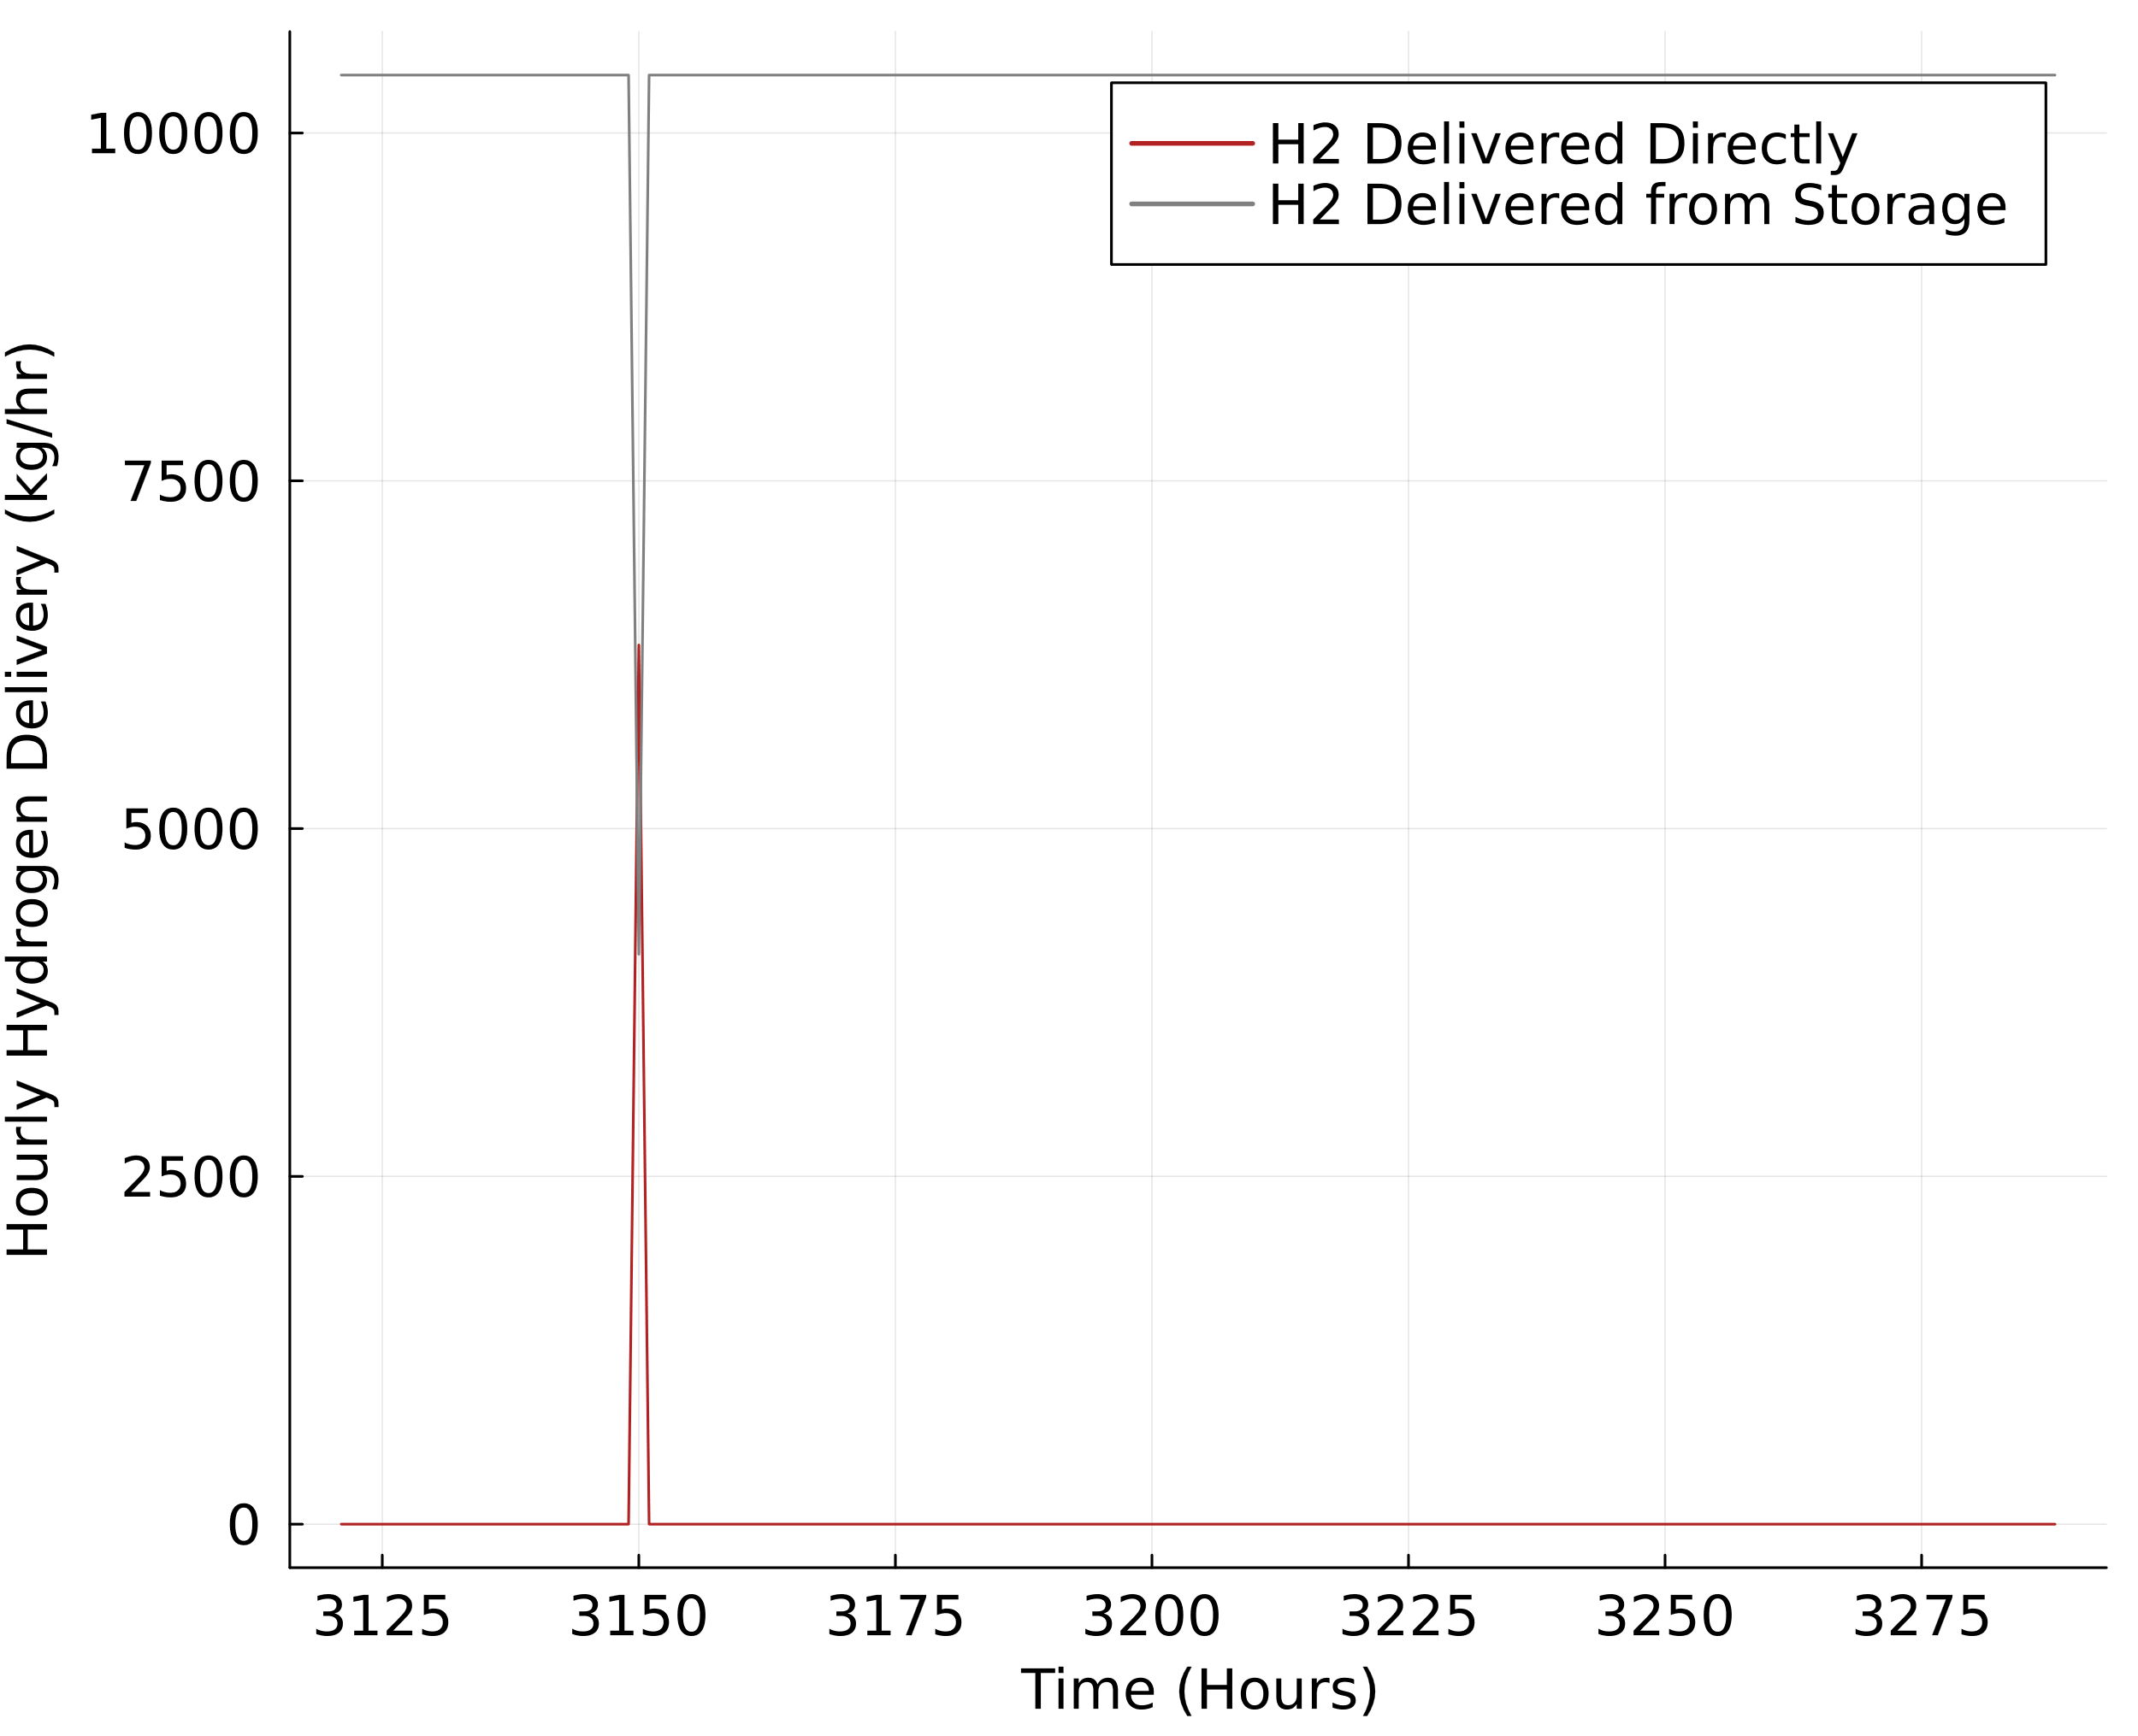

Figure S.19: Hourly hydrogen delivery for hourly reliable solar PV, storage, and limited grid connected hydrogen production pathway for a week in the month of May in Sacramento, California (Equivalent to PV/Storage/Grid** pathway).

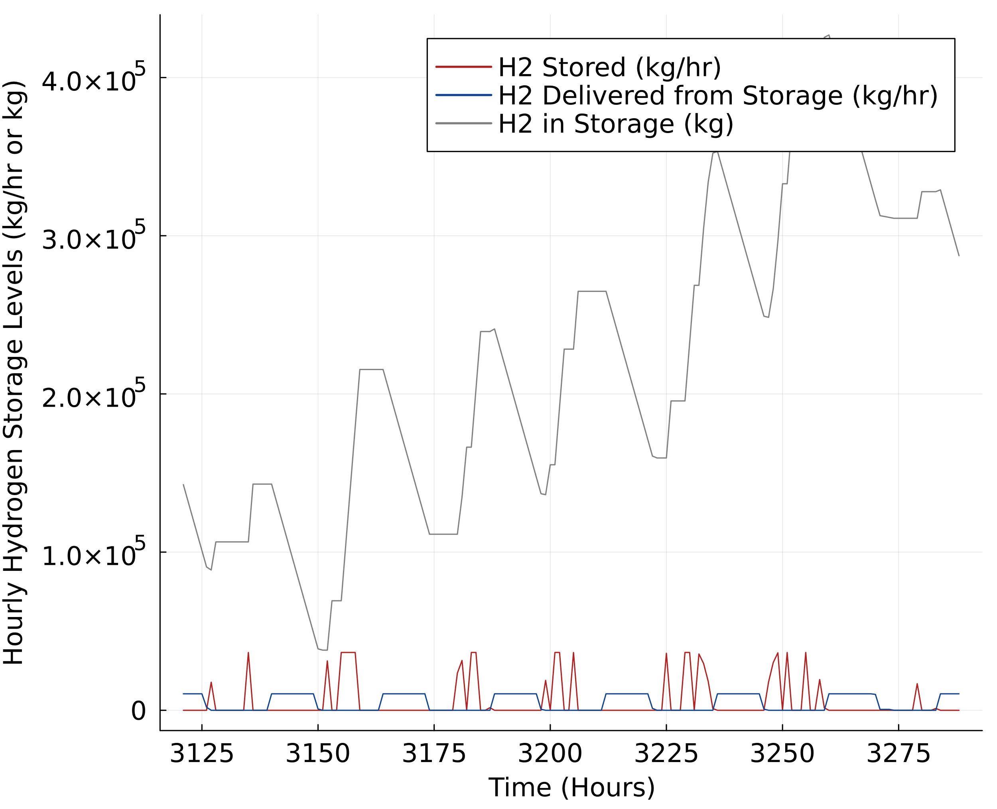

Figure S.20: Hourly hydrogen storage for hourly reliable solar PV and storage hydrogen production pathway for a week in the month of May in Sacramento, California (Equivalent to the PV/Storage pathway).

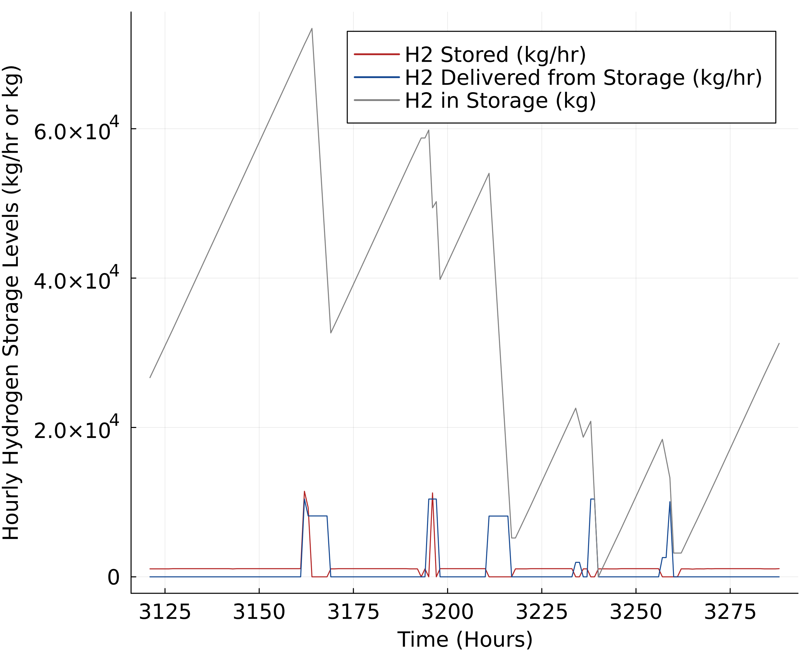

Figure S.21: Hourly hydrogen storage for hourly reliable solar PV, storage, and grid connected hydrogen production pathway for a week in the month of May in Sacramento, California (Equivalent to the PV/Storage/Grid* pathway).

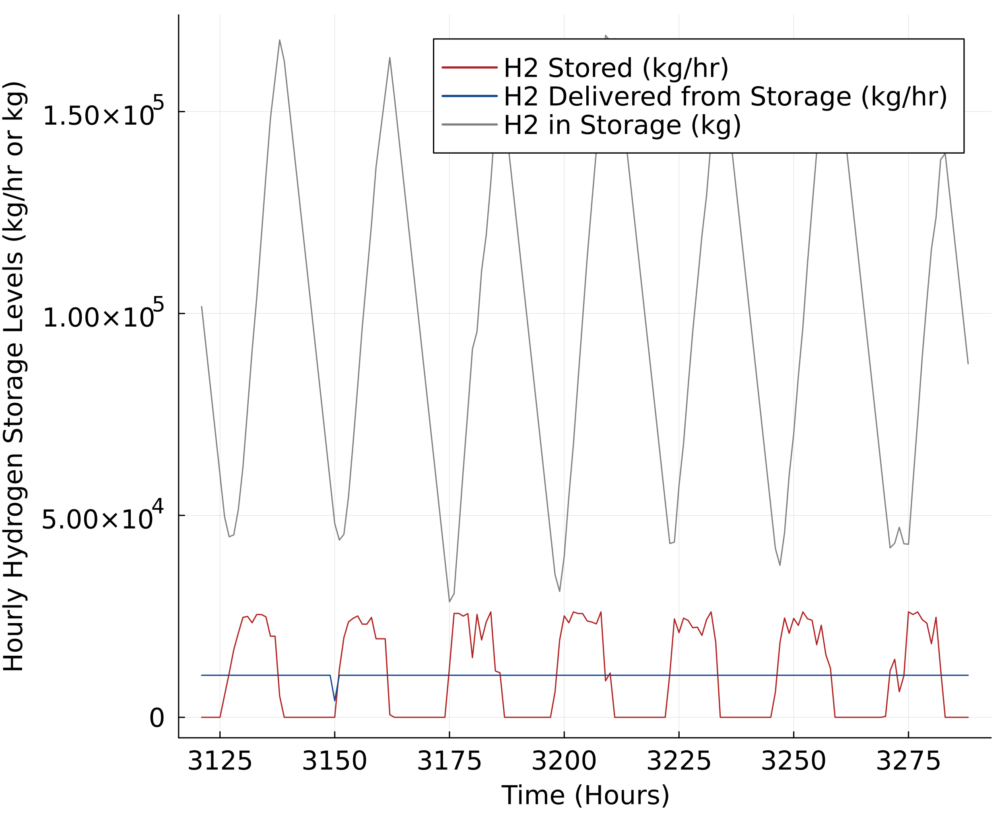

Figure S.22: Hourly hydrogen storage for hourly reliable solar PV, storage, and limited grid connected hydrogen production pathway for a week in the month of May in Sacramento, California (Equivalent to the PV/Storage/Grid** pathway).

## LCOH Figures with Current and Mid-Century Timeframes

This section contains LCOH figures found in the main text (Figures 3 and 4) but using current, next-decade, and mid-century technology input assumptions. We find that all hourly-reliable, net-zero hydrogen production costs fall significantly by mid-century in comparison to current costs.

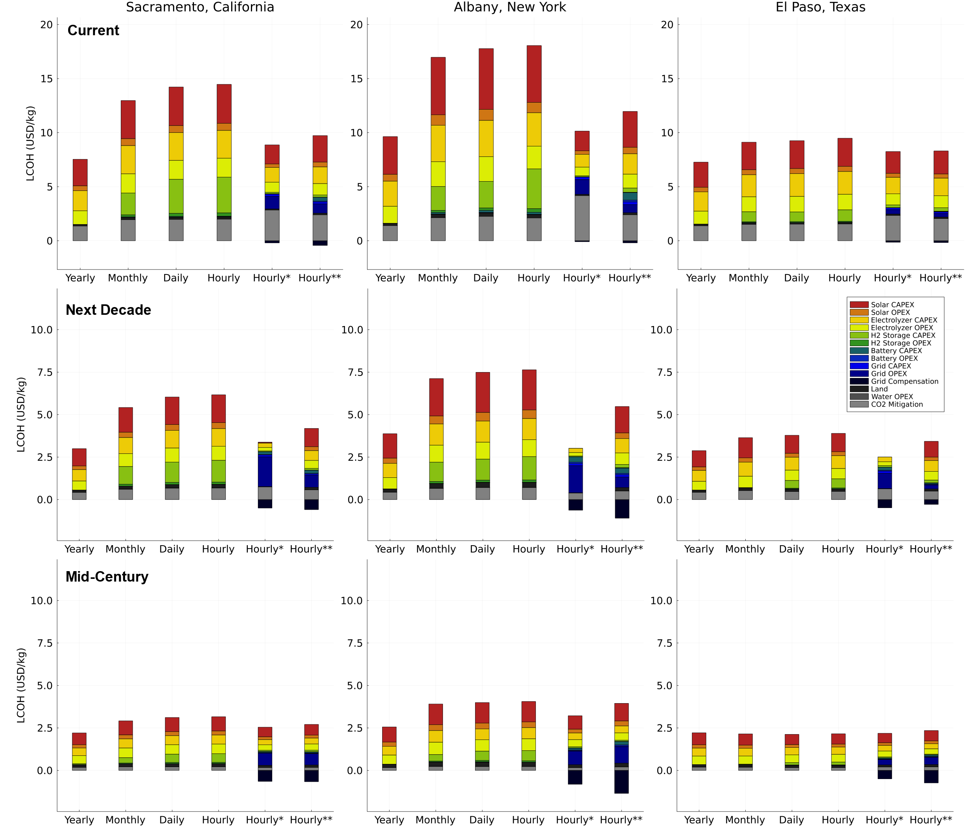

Figure S.23: Net-zero hydrogen production cost comparison between all electricity-based production pathways looking at all timeframes and locations.

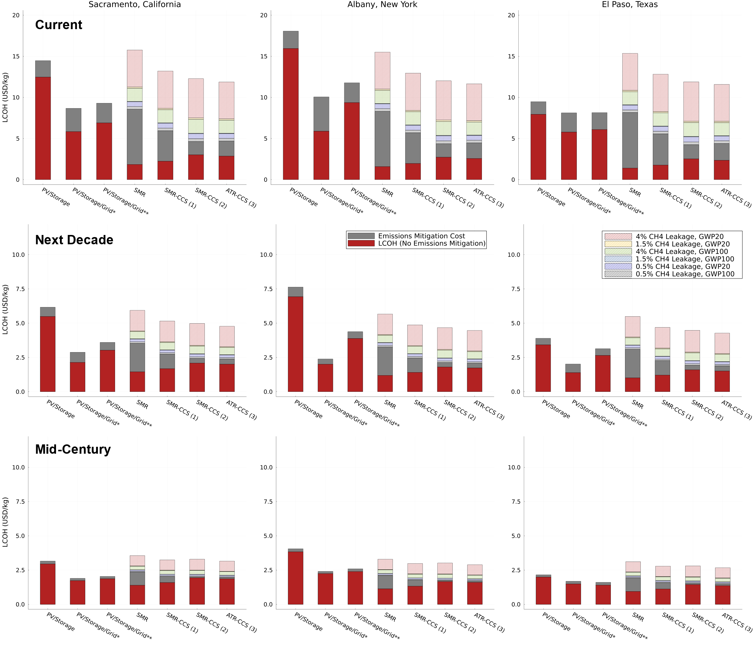

Figure S.24: Hourly reliable, net-zero hydrogen production cost comparison between electricity-based and fossil-based production pathways looking at all timeframes and locations

## Inflation Reduction Act Analysis with Current Technology Timeframe

This section contains a version of Figure 6 from the main text, but with current technology assumptions. As shown, even with embodied emissions excluded, the electricity-based pathways do not reach cost parity with fossil-based alternatives when tax credits from the Inflation Reduction Act are considered. This remains true for all locations explored in the study under the current technology assumption.

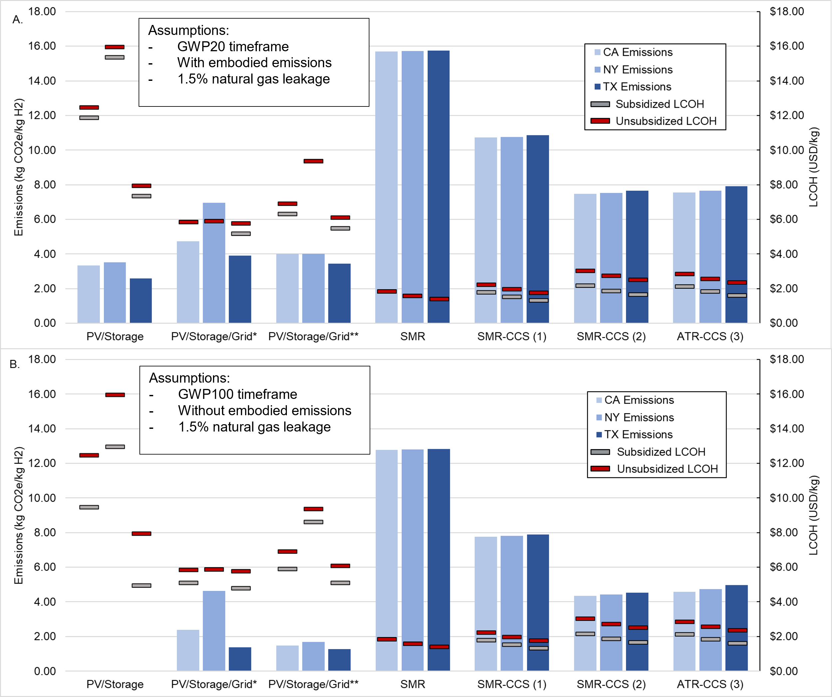

Figure S.25: Current technology IRA emission and cost analysis. (a) Total GHG emissions (in kg CO2e / kg H­2 produced), unsubsidized LCOH (in $/kg H2), and subsidized LCOH (in $/kg H2) for each hourly reliable hydrogen production pathway, for each state, assuming a 20-year GWP timeframe, 1.5% natural gas leakage, and including embodied emissions of electricity-generating sources. (b) Total GHG emissions (in kg CO2e / kg H­2 produced), unsubsidized LCOH (in $/kg H2), and subsidized LCOH (in $/kg H2) for each hourly reliable hydrogen production pathway, for each state, assuming a 100-year GWP timeframe, 1.5% natural gas leakage, and excluding embodied emissions. The subsidized LCOH values that consider 45V are valid for the first 10 years of project operation as defined in the IRA. The subsidized LCOH values that consider 45Q are valid for the first 12 years of project operation as defined in the IRA.







## References

[1] U.S. Bureau of Labor Statistics, “CPI Inflation Calculator,” 2023. https://www.bls.gov/data/inflation_calculator.htm.

[2] National Renewable Energy Laboratory, “System Advisor Model,” 2020. https://sam.nrel.gov/ (accessed Sep. 29, 2022).

[3] E. D. Sherwin, “Electrofuel Synthesis from Variable Renewable Electricity: An Optimization-Based Techno-Economic Analysis,” *Environ. Sci. Technol.*, vol. 55, no. 11, pp. 7583–7594, Jun. 2021, doi: 10.1021/ACS.EST.0C07955/SUPPL_FILE/ES0C07955_SI_001.PDF.

[4] Hydrogen Tools, “Lower and Higher Heating Values of Fuels,” 2023. https://h2tools.org/hyarc/calculator-tools/lower-and-higher-heating-values-fuels.

[5] National Renewable Energy Laboratory, “H2A-Lite: Hydrogen Analysis Lite Production Model,” 2022. https://www.nrel.gov/hydrogen/h2a-lite.html (accessed May 04, 2023).

[6] Y. Acevedo, J. Huya-Kouadio, K. McNamara, J. Prosser, and B. James, “Comparative Study of Levelized Cost of Hydrogen for Alkaline, PEM, AEM, and SOE Electrolyzer Plants,” 2023.

[7] M. Bolinger, R. Wiser, and E. O’Shaughnessy, “Levelized cost-based learning analysis of utility-scale wind and solar in the United States,” *Iscience*, 2022, Accessed: Nov. 22, 2022. [Online]. Available: https://www.sciencedirect.com/science/article/pii/S2589004222006496.

[8] National Renewable Energy Laboratory, “Annual Technology Baseline,” 2020. https://atb.nrel.gov/ (accessed May 02, 2023).

[9] J. Ramsden, T.; Kroposki, B.; Levene, “Opportunities for Hydrogen-Based Energy Storage for Electric Utilities. Golden,” pp. 1–17, 2008, [Online]. Available: nha.confex.com/nha/2008/recordingredirect.cgi/id/352.

[10] W. Cole, A. W. Frazier, and C. Augustine, “Cost Projections for Utility-Scale Battery Storage: 2021 Update,” 2021. Accessed: Apr. 22, 2023. [Online]. Available: www.nrel.gov/publications.

[11] W. Colella, B. D. James, J. M. Moton, G. Saur, and T. Ramsden, “Techno-economic Analysis of PEM Electrolysis for Hydrogen Production,” Golden, Colorado, Feb. 2014.

[12] Solar Land Lease, “Lease Rates for Solar Farms: How Valuable Is My Land?” https://www.solarlandlease.com/lease-rates-for-solar-farms-how-valuable-is-my-land (accessed May 28, 2021).

[13] National Renewable Energy Laboratory, “Distributed Generation Renewable Energy Estimate of Costs,” 2016. https://www.nrel.gov/analysis/tech-lcoe-re-cost-est.html (accessed May 28, 2021).

[14] P. Gagnon, B. Cowiestoll, and M. Schwarz, “Cambium 2022 Data,” 2023. [Online]. Available: https://scenarioviewer.nrel.gov/.

[15] O. Edenhofer *et al.*, “Renewable energy sources and climate change mitigation: Special report of the intergovernmental panel on climate change,” Cambridge University Press, 2012. doi: 10.1017/CBO9781139151153.

[16] United Nations, “Life Cycle Assessment of Electricity Generation Options,” 2021.

[17] National Renewable Energy Laboratory, “Identifying Potential Markets for Behind-the-Meter Battery Energy Storage: A Survey of U.S. Demand Charges,” 2017.

[18] National Renewable Energy Laboratory, “Energy Analysis: Life Cycle Assessment Harmonization,” 2012. https://www.nrel.gov/analysis/life-cycle-assessment.html (accessed Sep. 29, 2022).

[19] J. Gertner, “The Tiny Swiss Company That Thinks It Can Help Stop Climate Change,” *The New York Times*, 2019.

[20] National Energy Technology Laboratory, “Comparison of Commercial, State-of-the-Art, Fossil-Based Hydrogen Production Technologies,” 2022. [Online]. Available: https://www.osti.gov/servlets/purl/1862910/.

[21] J. Theis, “Cost Estimation Methodology for NETL Assessments of Power Plant Performance,” 2019. Accessed: Jan. 18, 2022. [Online]. Available: www.netl.doe.gov.

[22] U.S. Energy Information Administration, “Annual Energy Outlook 2023,” 2023. https://www.eia.gov/outlooks/aeo/ (accessed May 09, 2023).

[23] National Renewable Energy Laboratory, “H2A: Hydrogen Analysis Production Models,” 2018. https://www.nrel.gov/hydrogen/h2a-production-models.html (accessed Dec. 08, 2021).

[24] C. E. Clark, J. Han, A. Burnham, J. B. Dunn, and M. Wang, “Life-Cycle Analysis of Shale Gas and Natural Gas,” 2011. [Online]. Available: https://publications.anl.gov/anlpubs/2012/01/72060.pdf.

[25] J. De Chalendar, “Tracking emissions in the US electricity system,” *Stanford University*, 2022. https://gridemissions.jdechalendar.su.domains/#/ (accessed Sep. 29, 2022).

[26] Stanford University and Energy Futures Initiative, “An Action Plan for Carbon Capture and Storage in California: Opportunities, Challenges, and Solutions,” 2020. [Online]. Available: www.energy.stanford.edu.

[27] U.S. Environmental Protection Agency, “Understanding Global Warming Potentials,” 2022. https://www.epa.gov/ghgemissions/understanding-global-warming-potentials (accessed Oct. 06, 2022).

[28] R. W. Howarth and M. Z. Jacobson, “How green is blue hydrogen?,” *Energy Sci. Eng.*, vol. 9, no. 10, pp. 1676–1687, Oct. 2021, doi: 10.1002/ESE3.956.

[29] International Energy Agency, “Natural gas prices in Europe, Asia and the United States, Jan 2020-February 2022,” 2022. https://www.iea.org/data-and-statistics/charts/natural-gas-prices-in-europe-asia-and-the-united-states-jan-2020-february-2022.

[30] J. S. Rutherford *et al.*, “Closing the methane gap in US oil and natural gas production emissions inventories,” *Nat. Commun.*, Aug. 2021, doi: 10.1038/s41467-021-25017-4.

[31] Y. Chen *et al.*, “Quantifying Regional Methane Emissions in the New Mexico Permian Basin with a Comprehensive Aerial Survey,” *Environ. Sci. Technol.*, vol. 56, no. 7, pp. 4317–4323, 2022, doi: 10.1021/acs.est.1c06458.